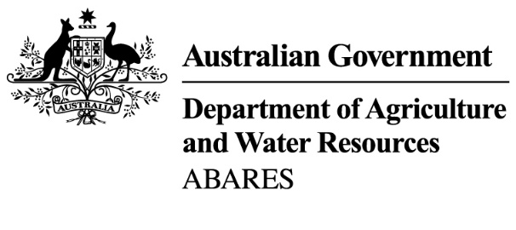

A model of water trade and irrigation activity in the southern Murray-Darling Basin

Mihir Gupta, Neal Hughes and Kai Wakerman Powell

**Research by the Australian Bureau of Agricultural  
and Resource Economics and Sciences**

Paper presented to the Australasian Agricultural & Resource Economics Society Annual Conference

February 2018



© Commonwealth of Australia 2018

Ownership of intellectual property rights

Unless otherwise noted, copyright (and any other intellectual property rights, if any) in this publication is owned by the Commonwealth of Australia (referred to as the Commonwealth).

**Creative Commons licence**

All material in this publication is licensed under a [Creative Commons Attribution 4.0 International Licence](https://creativecommons.org/licenses/by/4.0/legalcode) except content supplied by third parties, logos and the Commonwealth Coat of Arms.

Inquiries about the licence and any use of this publication should be emailed to [copyright@agriculture.gov.au](mailto:copyright@agriculture.gov.au).

by

**Cataloguing data**

Gupta, M, Hughes, N & Wakerman Powell, Kai 2018, A model for water trade and irrigation activity in the southern Murray-Darling Basin, ABARES conference paper, Canberra, January.

ISBN: 978-1-74323-374-0

ISSN: 1447-8358

Conference Paper No: 18.1

**Disclaimer**

The Australian Government acting through the Department of Agriculture and Water Resources, represented by the Australian Bureau of Agricultural and Resource Economics and Sciences, has exercised due care and skill in preparing and compiling the information and data in this publication. Notwithstanding, the Department of Agriculture and Water Resources, ABARES, its employees and advisers disclaim all liability, including for negligence and for any loss, damage, injury, expense or cost incurred by any person as a result of accessing, using or relying on information or data in this publication to the maximum extent permitted by law.

Acknowledgements

The authors thank Kenton Lawson for invaluable assistance in the preparation of datasets used for this report. The authors also thank David Galeano, Tim Goesch, Ahmed Hafi, Orion Sanders and Sally Thorpe for reviewing this report and providing helpful comments and suggestions. The authors also thank two anonymous referees from the Australasian Agricultural & Resource Economics Society (AARES) for their helpful comments. Comments on drafts of this paper were also received from staff in the Department of Agriculture and Water Resources.

Contents

About 4

Abstract 5

1 Introduction 6

2 Data 8

Data sources and assumptions 8

Total water supply and demand 11

3 Model 12

Water supply 12

Water demand 12

Water supply and demand balance 14

Water trading constraints 15

Solving for an equilibrium 16

Water entitlement prices 17

4 Estimation 18

Irrigation land use 18

Water application rate 23

Water demand in the NSW Lower Darling 26

Other water 26

5 Validation 27

Water allocation prices 27

Net trade flows 28

Irrigation activity 29

Entitlement prices 30

Performance of the baseline scenario 32

6 Conclusions 33

Future model development 33

Potential applications 34

7 References 35

Appendix A: Dataset construction 38

Rainfall 38

Allocations and carryover 40

Water allocation prices 40

ABS data 41

Commodity prices 47

Appendix B: Solution algorithm 49

Tables

Table 1 Key variables in the final dataset 8

Table 2 Regions in the sMDB analysed in this report 9

Table 3 Irrigation activities 10

Table 4 Trading zones, used for simulating inter-regional trade 15

Table 5 Annual trade constraints for trading zones in southern MDB (GL) 16

Table 6 Regression results for land use by irrigation activity, NSW Murrumbidgee 19

Table 7 Regression results for land use by irrigation activity, NSW Murray (above the Barmah Choke) 19

Table 8 Regression results for land use by irrigation activity, NSW Murray (below the Barmah Choke) 20

Table 9 Regression results for land use by irrigation activity, VIC Murray (above the Barmah Choke) 20

Table 10 Regression results for land use by irrigation activity, VIC Murray (below the Barmah Choke) 21

Table 11 Regression results for land use by irrigation activity, VIC Goulburn-Broken 21

Table 12 Regression results for land use by irrigation activity, VIC Loddon-Campaspe 22

Table 13 Regression results for land use by irrigation activity, SA Murray 22

Table 14 Regressions results for water application rate by irrigation activity 24

Table 15 Regressions results for water allocation demand, NSW Lower Darling 26

Table 16 Regressions results for other water use, by region 26

Table 17 Actual and modelled entitlement prices, as at June 2016 31

Table 18 Correlation between model estimates and actual data for key modelling outputs 32

Table A1 Data variables and sources 38

Table A2 Proportion of entitlements on issue above and below the Barmah choke, by type 40

Table A3 ABARES industry labels and groupings for water trade model 41

Table A4 ABS agricultural industry definitions and ABARES labels 42

Table A5 Percentage of irrigated area in NRM regions contained within water trade model regions, 2012 NRM boundaries 46

Table A6 ABARES commodity price sources and model activity groups 48

Figures

Figure 1 Total water use, annual diversions and allocation water supply in the sMDB 11

Figure 2 Modelling framework 13

Figure 4 Annual land use as a function of water allocation price, by irrigation activity 23

Figure 5 Total water use as a function of water allocation price, by irrigation activity 25

Figure 6 Total water use as a function of water allocation price, by region 25

Figure 7 Actual and modelled water allocation prices, by trading zone, 2002–03 to 2016–17 27

Figure 8 Actual and modelled net inter-zonal trade, by trading zone, 2002–03 to 2016–17 28

Figure 9 Actual and modelled total water use, by region, 2002–03 to 2016–17 29

Figure 10 Actual and modelled total irrigated land use, by region, 2002–03 to 2016–17 30

Figure 11 Modelled entitlement prices compared to actual prices 31

Figure A1 Average rainfall index across the sMDB, 2000–01 to 2015–16 39

Maps

Map 1 Southern Murray-Darling Basin water systems and major storages 9

Map A1 Rainfall, irrigated areas and water regions, 2015–16 39

About

This paper was prepared for the 2018 Australasian Agricultural & Resource Economics Society (AARES) Conference. The paper presents a new economic model of water trade and irrigation activity within the southern Murray-Darling Basin (sMDB), developed by ABARES on behalf of the Department of Agriculture and Water Resources. This model extends a similar model previously developed by ABARES (see Hughes et al. 2016). The model remains under ongoing development, a number of planned improvements to the model are documented in the paper.

This report remains technical in nature and documents the model data sources and assumptions. The only results presented in this paper are provided for the purposes of validating the models performance. The model has a range of potential future applications, such as assessing the effects on sMDB water markets and irrigation industries of: water policy reforms, water trading rules, changes in water availability or changes in perennial plantings.

Abstract

This paper presents a new econometric partial equilibrium model of water trade and irrigation activity within the southern Murray-Darling Basin (sMDB). The model exploits a unique data set detailing water availability, water market outcomes, irrigation activity, climate conditions and commodity prices for the sMDB annually over the period 2002–03 to 2016–17. This data is used to econometrically estimate a set of demand functions for water by region and irrigation activity. These demand functions are placed within a spatial equilibrium framework taking into account constraints on inter-regional water trade across the basin. The model is able to simulate the market prices of water allocations and entitlements by region and inter-regional water trade flows along with water and land use by irrigation activity and region. The performance of the model is demonstrated with in and out-of-sample validation tests. The model provides a basis for separating the effects of historical climate, market and policy shocks on the region and for simulating the effects of potential future shocks.

# Introduction

The irrigation industry of the southern Murray–Darling Basin (sMDB) has been subject to a wide range of climate, market and policy changes over the last two decades.

Firstly, there have been dramatic variations in water availability including the ‘Millennium drought’ and subsequent floods, along with a longer-term trend toward reduced winter rainfall in the region related to climate change (CSIRO 2012). In addition, changes in commodity prices have placed adjustment pressure on the industry, leading to a contraction in wine grape plantings and recent expansions in almonds and cotton. At the same time, there have been a number of new government policies, including the Water Act 2007 and Murray–Darling Basin Plan, focused on reallocating water from irrigation to environmental uses.

The other major development during this period has been the continued growth and evolution of water markets. The sMDB water allocation market is now widely regarded as one of the most advanced of its kind in the world particularly given its ability to facilitate large volumes of trade between water users in different river catchments.

Understandably, there remains strong interest from policy makers in models and other tools for analysing water trade and irrigation activity in the sMDB, with the capacity to separate the effects of different historical climate, market and policy shocks, and to simulate the effects of potential future shocks.

This paper presents a new econometric partial equilibrium model of water trade and irrigation activity is presented. This model attempts to reconcile two alternative approaches applied in the literature: reduced form econometric estimation of water demand using historical market price data (see Brennan 2006, Bjornlund and Rossini 2005 and Wheeler et al. 2008) and ‘bottom-up’ construction of water demand through structural bio-economic optimisation models (see Apples, Douglas and Dwyer (2004) or Qureshi, Ranjan and Qureshi (2010) for a review).

Similar to Brennan (2010) and Hughes et al. (2016) this study involves econometrically estimating a series of short-run (annual) water demand functions which are then placed within a spatial equilibrium framework to simulate water market prices and trade flows across the sMDB. As with Brennan (2010) and Hughes et al. (2016) the model takes into account limits on water allocation trade between regions as defined by prevailing water trading rules. This is significant as in recent years, constraints on interregional water trade have become an important issue within the sMDB. A number of water trade rules, most notably limits on the export of water from the Murrumbidgee have started to affect the market leading to differences in water prices between regions (ABARES 2017).

The model presented in this paper, extends that of Hughes et al. (2016) by including an irrigation component, which estimates demand for irrigation water (and land) by region and activity (i.e., crop type). In this sense, the model provides outputs similar to previous bio-economic models of irrigation in the region, of which there is a long tradition (see for example Hall at al. 1994, Adamson et al. 2007, Hafi et al. 2009, Grafton and Jiang 2011 and Qureshi et al. 2013).

Previous models have employed a range of mathematical programming techniques particularly linear programming, which is subject to number of well documented limitations including “a tendency towards over-specialisation in production and resource allocation” (Qureshi et al. 2013). A range of pragmatic calibration methods have evolved to address these limitations - including Positive Mathematical Programming (PMP). However, these calibration methods remain subject to their own limitations (Heckelei and Wolff 2003, Doole and Marsh 2014).

The model in this paper does not use calibration techniques, rather the parameters are all estimated econometrically using historical data. The basis for this approach is a unique data set detailing water availability (allocation percentages, entitlement volumes and carryover), market outcomes (prices and trade flows), irrigation activity (water and land use), climate (rainfall) and commodity prices for a consistent set of sMDB regions annually over the period 2002–03 to 2016–17.

This data set combines a variety of data sources, including state government water agencies, the Australian Bureau of Statistics (ABS) and the Australian Bureau of Agricultural and Resource Economics and Sciences (ABARES). Given inconsistencies between data sets and changes in data collections over time, construction of the data set requires some approximation which creates a risk of measurement error. Despite this the data set is sufficient to generate realistic water demand responses and produce a model which achieves good validation performance both within and out-of-sample.

This paper is structured as follows. Chapter 2 summarises the data set and the key assumptions involved in its construction, with a complete description of the data is provided in Appendix A. Chapter 3 outlines the structure of the model, while Chapter 4 describes the estimation of the parameters. Chapter 5 presents some within and out-of-sample validation tests of the model under a baseline scenario which describes historical market conditions. Finally Chapter 6 outlines some of the strengths and weaknesses of the model and some options for future refinements and application.

# Data

## Data sources and assumptions

The model data is built from number of sources (listed in Table A1). There are two key components; the first is a dataset on water market outcomes (water market prices and trade volumes), water availability (water allocation, carryover and storage volumes) and climate conditions (rainfall) for each of the major sMDB regions for the years 2002–03 to 2016–17, based on data previously collated by Hughes, Gupta & Rathakumar (2016). The second component is a dataset detailing irrigation water and land use on farms in the sMDB (ABS 2016b) drawing on annual ABS agricultural census and surveys between 2002–03 and 2015–16.

The construction of this dataset involved significant effort given the large number of data sources and various inconsistencies between them. In particular, a number of modifications to the original sources were required to compile the data into a consistent set of regional and industry definitions. The assumptions made in constructing the final data set are described in Appendix A and summarised below. Table 1 details the key variables contained in the final data set.

Table Key variables in the final dataset

|  |  |
| --- | --- |
| Variable | Description |
| Climate | |
| $$R_{it}$$ | Average farm rainfall (mm) in region $i$ in year $t$ |
| **Irrigation water use and area** | |
| $$W_{ijt}$$ | Water use (ML) in activity $j$ in region $i$ in year $t$ |
| $$L_{ijt}$$ | Land use (HA) for activity $j$ in region $i$ in year $t$ |
| **Commodity prices** | |
| $$Y_{ijt}$$ | Output price index for activity $j$ in region $i$ in year $t$ |
| **Water allocations and entitlements** | |
| $$E_{iht}$$ | Water entitlement volume (ML) in region $i$ for reliability type $h$ in year $t$**a** |
| $$a_{iht}$$ | Allocation percentage (%) for entitlement reliability type *h* in region $i$ during year $t$ |
| $$c_{it},{\overline{c}}_{it}$$ | Allocation (ML) carried over from previous year / carried forward to next year in region *i* year *t* |
| $$Δ_{it}$$ | Net inter-region water allocation trade (ML) for region $i$ during year $t$**b** |
| $$P_{it}$$ | Average annual water allocation price ($ / ML) in region $i$ during year $t$ |

Note: **a** Entitlement volumes are those available for consumptive use after removing Commonwealth water entitlement purchases for the environment (see Hughes et al. 2016 or Appendix A for detail). **b** Inter-regional trade flows exclude non-market environmental transfers

### Regions

In this report the sMDB is defined to include the Murray River, the Murrumbidgee and Lower Darling systems, and the Goulburn, Broken, Loddon and Campaspe systems. The precise regions included in this dataset are detailed in Table 2 and Map 1 below.

Water allocation and market data (water prices, allocations, carryover, environmental purchases, storage volumes and trade) was available for most of these regions from the previous dataset of Hughes et al. (2016). Some additional work was required to separate the above and below Barmah segments of the NSW and Vic. Murray regions (see Appendix A for detail).

Water use and irrigation area data was available from the ABS at the Natural Resource Management (NRM) region level. In some cases NRM region boundaries closely match the region definitions used in this report (e.g., Murrumbidgee), while in other cases they are substantially different, such as the Victorian (Vic.) Murray. For this study, ABS NRM region data was apportioned to match the regions defined below, using spatial land use mapping data, as described in Appendix A. Prior to 2005–06 ABS data is only available at Statistical District (SD) region level. The same method was applied to map this data to the regions used in this report. Future work could make use of ABS unit record data to construct more precise regional estimates (see chapter 6 for detail).

Table Regions in the sMDB analysed in this report

|  |  |
| --- | --- |
| $$i$$ | Regions |
| 1 | NSW Murray (above Barmah) |
| 2 | Vic. Murray (above Barmah) |
| 3 | Vic. Goulburn-Broken |
| 4 | Vic. Loddon-Campaspe |
| 5 | NSW Murrumbidgee |
| 6 | NSW Lower-Darling |
| 7 | NSW Murray (below Barmah) |
| 8 | VIC Murray (below Barmah) |
| 9 | SA Murray |

Map Southern Murray-Darling Basin water systems and major storages

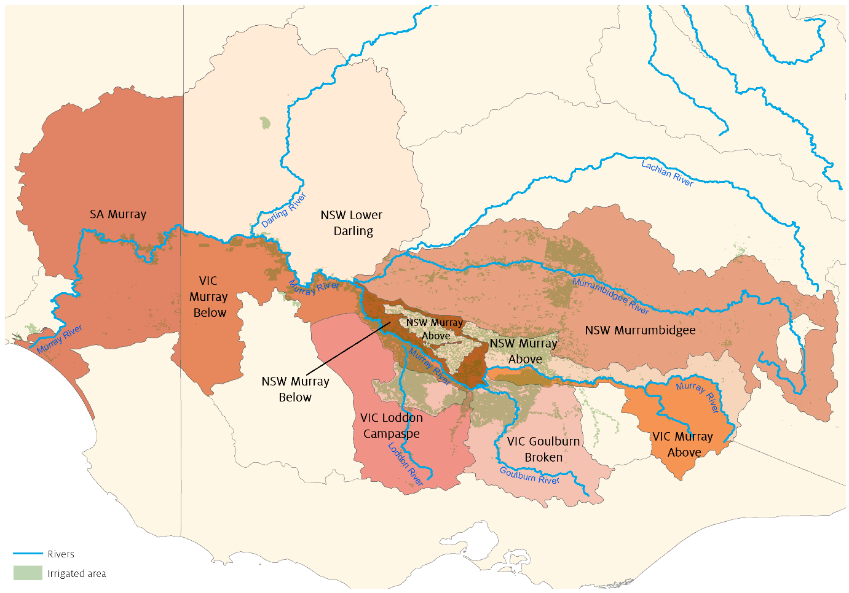

### Irrigation activities

The dataset and model presented in this paper include the irrigation activities shown in Table 3. As the definitions for irrigations activities used by the ABS have changed over time, a complete mapping between ABS activity types and those used in the final data set is presented in Appendix A.

Table Irrigation activities

|  |  |
| --- | --- |
| $$j$$ | Irrigation activities |
| 1 | Pastures – Grazing (Dairy) |
| 2 | Pastures – Hay |
| 3 | Cotton |
| 4 | Rice |
| 5 | Other cereals |
| 6 | Other broadacre |
| 7 | Other crops |
| 8 | Grapes |
| 9 | Fruits and nuts |
| 10 | Vegetables |

### Entitlement types

Following Hughes et al. (2016) only regulated surface water entitlements are accounted for in each region. This includes ‘General security’ and ‘High security’ entitlements in NSW regions. ‘High reliability’ and ‘Low reliability’ in Victoria and Class 3 in South Australia. For notation purposes entitlement types are indexed by: $h∈\left\{high,low\right\}$ (with, for example, NSW General Security referring to type *low*). Data is compiled for entitlement and allocation volumes for these entitlement types and is discussed further in Appendix A.

### Time

The dataset contains water allocation and market data on a financial year basis between 2002–03 to 2016–17. As mentioned previously, ABS water and land use data by irrigation activity and NRM region is available from 2005–06. From 2002–03 to 2004–05, data is only available for total water use and land use by SD regions.

The sample used for econometric estimation of water and land use demand functions was limited to the period 2005–06 to 2015–16. Data for the years 2002–03 to 2004–05 and 2016-17 are withheld from estimation and used for out-of-sample model validation.

## Total water supply and demand

One of the challenges with the dataset is reconciling water supply and demand, given data for each has been obtained from different sources. Water supply is measured in terms of water allocations and reflects the volume available for use against major regulated surface water entitlements. Water use numbers reflect water applied by farmers as reported in surveys. There are a variety of legitimate reasons why historical water allocation and water use numbers may differ (beyond the measurement error present in both data sources), including:

* Additional sources of water supply not included in the allocation data (such as groundwater and unregulated water)
* Non-irrigation water use (such as urban or stock and domestic) against regulated surface water entitlements (although in practice these activities are normally supported by separate entitlements)
* Forfeited water (where allocations are not used, traded or carried over by farmers)

Figure 1 shows total irrigation water use in the sMDB, against water allocations available for use (after accounting for carryover and environmental recovery) as recorded in the dataset. The chart also shows annual diversions (an alternative measure of water demand) as reported by the Murray Darling Basin Authority (MDBA).

Despite the potential for error, water allocation and total water use remain similar over the period. The largest differences are observed during the flood period (2010–11 to 2012–13) where allocations exceed water use (likely due to forfeited allocations). As expected, diversions are higher than water use and allocations, given they include system losses and non-irrigation water use (e.g., urban, stock and domestic etc.). Despite this, diversions are closely related to water use and allocations over time.

The model developed in this study has the flexibility to allow for legitimate sources of difference in measures of water supply and demand (see Chapter 3 for detail). Future research, could help reduce measurement error in each of these (see chapter 6).

Figure Total water use, annual diversions and allocation water supply in the sMDB

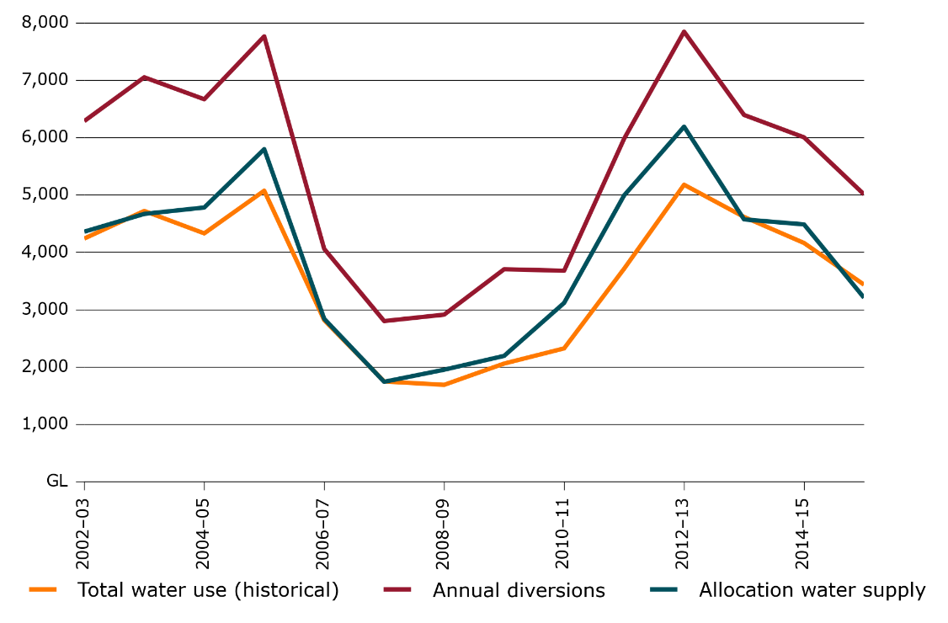

# Model

The model uses a spatial partial equilibrium framework and runs on an annual time step for financial years. Each region has an initial allocation of water (given entitlement volumes and annual allocation percentages), and this water can be traded between activities and across regions subject to defined trading rules. Equilibrium prices are those which maximise the benefits of water use (and equalise the marginal value of water) subject to constraints on trading (Figure 2).

The model has a short-run focus, simulating the demand for water allocations (by region and irrigation sector) in each year given prevailing water availability, rainfall and commodity prices. The model does not attempt to represent longer-term (i.e., between year) industry adjustment. In practice, longer term changes in irrigation water demand (e.g., changes in the mix of perennial vs annual crops,) depend on expectations over future conditions / market prices. Proper representation of these changes requires explicit consideration of risk and uncertainty (see Brennan 2006, Adamson et al. 2017) which remains outside the scope of this study.

## Water supply

In this framework, allocation water supply is exogenous and is estimated after accounting for carryover and environmental purchases. Allocations available in region $i$ prior to trade are defined as:

$$A_{it}=\sum^{h∈H}{\left(E_{iht}.a_{iht}+c_{iht}-{\overline{c}}_{iht}\right)} (1)$$

Here entitlement volumes are those available for consumptive use (after adjusting for environmental purchases), while allocation percentages are ‘final’ (those prevailing at the end of the financial year). The above equation accounts for carryover from the previous year and carryover into the next year which are both taken as exogenous.

## Water demand

Water allocation demand is estimated for each irrigation activity in each region based on the schematic illustrated in Figure 2.

### Irrigation land use

For activities 8 and 9 (grapes and fruit and nuts) land use $L_{ijt}$ is taken as exogenous and set to historical values (based on the prevailing annual land areas in the dataset). Perennial land areas can be varied for the purposes of scenario analysis as discussed further in the conclusions.

For other activities annual land use by region is defined as a function of water allocation prices, rainfall and commodity prices (equation 2) where $β_{ij}^{L}$ are parameters to be estimated.

$$L_{ijt}=f^{L}(P_{it},R_{it},Y_{jt},{t, β}_{ij}^{L}) (2)$$

The exception to this is cotton, where there is insufficient sample to estimate land use functions (because cotton only appeared in the sMDB in 2010–11). To address this, a single function is estimated for the total cotton and rice irrigated area. Individual areas for these activities are then based on the observed historical proportions of rice to cotton in each region.

Figure Modelling framework



### Water application rate

The water application rate is defined for each irrigation activity as a function of the water allocation price, commodity price and rainfall (equation 3), where $β_{ij}^{W}$ are parameters to be estimated.

$$W_{ijt}/L_{ijt}=f^{W}(P_{it},R_{it},Y_{jt},{t, β}_{ij}^{W}) (3)$$

### Irrigation water use

Together the land use and water application functions (equation 2 and 3) define a water demand function (equation 4), simulating irrigation water use for irrigation activity $j$ in region $i$ in period *t:*

$$W_{ijt}=d^{W}(P_{it},R_{it},Y_{jt}) (4)$$

For convenience, regional level total water demand functions can be defined as:

$$W_{it}=\sum^{j∈J}{d^{W}}(P_{it},R_{it},Y_{jt})=D_{i}(P_{it},R_{it},Y_{it})$$

$$W_{jt}=\sum^{i∈I}{W_{ijt}}$$

## Water supply and demand balance

### Other water

As discussed, there are a variety of reasons why estimates of historical water supply in each region $A_{it}+Δ_{it}$ may differ from total irrigation water use $W_{it}$.

To address this we define the variable $O_{it}$ as net ‘other water‘ to take into account errors or differences between irrigation water use and allocation water supply:

$$O_{it}=W_{it}-(A_{it}+Δ_{it})$$

In practice, $O_{it}$ can be either positive or negative. Positive values reflect net additional water supply (i.e., from groundwater or unregulated sources) while negative values reflect net additional water use (i.e., non-irrigation water use or forfeited allocations).

Within the model other water use in region $i$ is defined as a function of the water allocation price and rainfall (assuming that other water is a substitute for allocation water).

$$O_{it}=f^{O}(P_{it}, R_{it},β_{i}^{O}) (5)$$

### Water supply constraint

For each region $i$ and time period $t$, total water demand must then equal the sum of allocation water supply, net trade for the region and other water use. This is also referred to as the water supply constraint:

$$W_{it}=A_{it}+Δ_{it}+O_{it} (6)$$

## Water trading constraints

The model has been designed to take into account key historical restrictions on inter-regional water trade in the sMDB including:

* Murrumbidgee import and export limits
* Northern Victoria import and export limits
* Lower-Darling trade limits enforced during drought conditions
* Barmah choke trade limits.

In order to represent these limits, 5 trading zones are defined in the model (Table 4). These trading zones are aggregations of regions, where each region within a trading zone can freely trade with all other regions in the same trading zone.

Table Trading zones, used for simulating inter-regional trade

|  |  |
| --- | --- |
| $$k$$ | Trading zones |
| 1 | Murray above Barmah, $I_{1}=\{1,2\}$ |
| 2 | Northern VIC, $I_{2}=\{3,4\}$ |
| 3 | Murrumbidgee, $I_{3}=\{5\}$ |
| 4 | Lower-Darling, $I_{4}=\{6\}$ |
| 5 | Murray below Barmah, $I_{5}=\{7,8,9\}$ |

Note: For the model equations, trading zones are represented by: $k∈\{1,....,5\}$ and $I_{k}⊂I$ as listed in Table 2

For each trading zone annual net trade must remain within a predefined lower and upper limit:

$${\underset{̲}{Δ}}_{kt}≤Δ_{kt}≤{\overline{Δ}}_{kt} (8)$$

These upper and lower trade limits can be set to reflect prevailing trading rules within the sMDB in each year. The baseline parameters used in this paper are listed in Table 5 and are based on an analysis of historical annual trade flow data (see Hughes et al. 2016).

Table Annual trade constraints for trading zones in southern MDB (GL)

|  |  |  |  |  |  |  |  |  |  |  |
| --- | --- | --- | --- | --- | --- | --- | --- | --- | --- | --- |
| **Year** | **Murrumbidgee** | | **Northern Victoria** | | **Lower-Darling** | | **Murray**  **above Barmah** | | **Murray**  **below Barmah** | |
| TL | TU | TL | TU | TL | TU | TL | TU | TL | TU |
| 2003 | -200 | 0 | no limit | 50 | 0 | 0 | 0 | no limit | no limit | no limit |
| 2004 | -200 | 0 | no limit | 50 | 0 | 0 | 0 | no limit | no limit | no limit |
| 2005 | -200 | 0 | no limit | 50 | no limit | no limit | 0 | no limit | no limit | no limit |
| 2006 | -200 | 0 | no limit | 50 | 0 | 0 | 0 | no limit | no limit | no limit |
| 2007 | no limit | 0 | no limit | 50 | 0 | 0 | 0 | no limit | no limit | no limit |
| 2008 | no limit | 0 | no limit | 50 | 0 | 0 | no limit | no limit | no limit | no limit |
| 2009 | no limit | 0 | no limit | 50 | no limit | no limit | no limit | no limit | no limit | no limit |
| 2010 | no limit | 0 | no limit | 50 | -68 | 0 | no limit | no limit | no limit | no limit |
| 2011 | -200 | 0 | -150 | 50 | no limit | no limit | no limit | no limit | no limit | no limit |
| 2012 | -200 | 0 | -150 | 50 | no limit | no limit | no limit | no limit | no limit | no limit |
| 2013 | -200 | 0 | -150 | 50 | no limit | no limit | no limit | no limit | no limit | no limit |
| 2014 | -200 | 0 | -150 | 50 | no limit | no limit | no limit | no limit | no limit | no limit |
| 2015 | -200 | 0 | -150 | 50 | 0 | 0 | -26 | no limit | no limit | no limit |
| 2016 | -200 | 0 | -150 | 50 | 0 | 0 | -26 | no limit | no limit | no limit |
| 2017 | -200 | 0 | -150 | 50 | no limit | no limit | -37 | no limit | no limit | no limit |

Note: TL Lower trade limit; TU Upper trade limit.

## Solving for an equilibrium

A solution to the model is given by a set of equilibrium allocation prices $P_{it}^{*}$ for each region (or equivalently net trade volumes) which maximise water use benefits based on the integral of the demand function:

$$\max_{P_{it}}\sum^{i∈I}{\int_{A_{it}+Δ_{it}}{D_{i}^{-1}}}(W_{it},...)$$

The solution must also satisfy the market clearing, water demand and water supply conditions and trade constraints:

$$\sum^{i∈I}{Δ_{it}}=0$$

$${\underset{̲}{Δ}}_{kt}≤Δ_{kt}≤{\overline{Δ}}_{kt}$$

$$W_{ijt}=d^{W}(P_{it},R_{it},Y_{ijt})$$

$$W_{it}=\sum^{j ∈ J}{W_{ijt}}=A_{it}+Δ_{it}+O_{it}$$

Rather than directly computing the integral, a set of equilibrium prices are obtained subject to these conditions using a numerical algorithm which is further described in Appendix B.

## Water entitlement prices

The model can also be used to simulate water entitlement prices. Water entitlements are assets which provide annual returns in the form of water allocations. The simplest approach to valuing entitlements (ignoring issues of risk) is to assume that entitlement prices are equal to the discounted expected value of future allocations:

$$V_{ihs}=\sum_{t=s+1}^{∞}{\frac{1}{{\left(1+r\right)}^{t}}}E_{s}\left[a_{iht} .P_{it}\right]$$

Where $V_{ihs}$ is the price of water entitlement $h$ in region $i$ period $s$ and *r* is the discount rate parameter.

In the model, the unobservable expectation $E_{s}\left[a_{iht}.P_{it}\right]$ is replaced with the sample average for the period 2002–03 to 2016–17. Water entitlement prices can then be approximated as:

$$V_{ihs}=\left(\frac{1}{r}\right)\frac{1}{15}\sum_{t=2003}^{t=2017}{\left[a_{iht} P_{it}\right] (9)}$$

This approach assumes that historical water availability and market conditions are a reasonable reflection of future expectations. As such, when attempting to predict current entitlement prices the model baseline is adjusted such that current levels of environmental water recovery are applied from the beginning of the period. A real discount rate of 7 per cent was assumed for this report.

# Estimation

Parameters for the land use, water application rate and other water use functions (equations 2, 3 and 5) were estimated via linear Ordinary Least Squares (OLS) regression. Regression results are presented below; further detail including standard diagnostic tests are available on request. To ensure theoretically plausible results (including downward sloping demand functions) constraints are applied to model coefficients. However, as shown in the following sections, these are rarely binding.

In testing, a variety of functional forms for these regression models were considered, with simple linear forms ultimately being adopted. Throughout this testing phase, more focus was placed on the performance of model outputs (as measured through validation tests, see chapter 5) than the in-sample fit of the individual regression models themselves. A more formal structural estimation approach (where model equations are estimated simultaneously) remains a potential topic for future research.

## Irrigation land use

For equation 2, we fit the following model for each region and activity:

$$L_{ijt}=β_{0i}^{L}+β_{1ij}^{L}.P_{it}+β_{2ij}^{L}R_{it}+β_{3ij}^{L}Y_{it}+β_{4ij}^{L}.t (10)$$

subject to the following constraints:

$$β_{1ij}^{L}<0,β_{3ij}^{L}>0$$

As discussed irrigated area for perennial activities is currently treated as exogenous. Tables 6 – 13 show the results of model estimation for land use for annual irrigation activities in each region. Note that the sample size for each of these models is 11 (2005–06 to 2015–16).

In Tables 6 – 13 omitted variables are the result of parameters not satisfying the constraints set out above. In all cases, except for vegetables in the VIC Goulburn-Broken and VIC Loddon-Campaspe regions, and other broadacre in SA Murray, the parameters for water allocation price have the desired negative sign. Further, the majority of price coefficients are significant at the five per cent level.

Note that while ABS data suggests that rice activity occurs in Victorian regions, it remains close to zero in most years and well below the levels observed in NSW. Based on available ABS and ABARES data, cotton and rice are not grown in the SA Murray, and are excluded from model estimation for this region (Table 13).

Table 6 Regression results for land use by irrigation activity, NSW Murrumbidgee

|  |  |  |  |  |  |  |  |
| --- | --- | --- | --- | --- | --- | --- | --- |
| **Industry** | **Constant** | **Price (P)** | **Output price (Y)** | **Cotton**  **price (CY)** | **Rainfall (R)** | **Time (t)** | **R2** |
| Cotton-Rice | 64738.83* | -117.71* |  |  | -15.65 | 2003.03 | 0.76 |
|  | (0.05) | (0.01) |  |  | (0.75) | (0.36) |  |
| Vegetables | -9417.51 | -3.28 | 121.13 |  | -2.73 | -843.29 | 0.45 |
|  | (0.52) | (0.28) | (0.30) |  | (0.49) | (0.16) |  |
| Other broadacre | 9821.05 | -25.4* | 90.79 |  | -8.87 | -864.44 | 0.73 |
|  | (0.21) | (0.01) | (0.21) |  | (0.22) | (0.09) |  |
| Other cereals | 89672.90 | -120.29 | 484.93 |  | -86.65 | -3353.19 | 0.55 |
|  | (0.14) | (0.08) | (0.36) |  | (0.12) | (0.34) |  |
| Other crops | -966.20 | -5.53 | 41.05 |  | -4.19 | -26.74 | 0.61 |
|  | (0.86) | (0.06) | (0.41) |  | (0.15) | (0.87) |  |
| Pastures - Dairy | 54313.64* | -78.97* | 326.72 |  | -39.10 | -6624.52* | 0.87 |
|  | (0.04) | (0.01) | (0.18) |  | (0.10) | (0.00) |  |
| Pastures - Hay | 34140.3* | -22.48* |  |  | -18.95 | -2096.14* | 0.78 |
|  | (0.00) | (0.02) |  |  | (0.12) | (0.00) |  |

Note: * denotes significance at the 95% level

Table 7 Regression results for land use by irrigation activity, NSW Murray (above the Barmah Choke)

|  |  |  |  |  |  |  |  |
| --- | --- | --- | --- | --- | --- | --- | --- |
| **Industry** | **Constant** | **Price (P)** | **Output  price (Y)** | **Cotton  price (CY)** | **Rainfall (R)** | **Time (t)** | **R2** |
| Cotton-Rice | 49162.31* | -75.81* |  |  | -38.60 | 510.25 | 0.81 |
|  | (0.01) | (0.00) |  |  | (0.17) | (0.61) |  |
| Vegetables | 1124.67* | -0.77 |  |  | 0.61 | -58.95* | 0.62 |
|  | (0.02) | (0.10) |  |  | (0.35) | (0.04) |  |
| Other broadacre | 8710.38* | -15.51* | 25.74 |  | -13.42* | 273.82 | 0.92 |
|  | (0.04) | (0.00) | (0.39) |  | (0.01) | (0.21) |  |
| Other cereals | 79171.99* | -73.96* |  |  | -76.06* | 410.30 | 0.79 |
|  | (0.00) | (0.00) |  |  | (0.02) | (0.68) |  |
| Other crops | -742.82 | -0.85 | 9.97 |  | -0.91 | 56.47 | 0.81 |
|  | (0.51) | (0.14) | (0.32) |  | (0.19) | (0.13) |  |
| Pastures - Dairy | 129720.75* | -134.46* | 133.67 |  | -122.48* | -3018.63 | 0.83 |
|  | (0.01) | (0.00) | (0.66) |  | (0.02) | (0.20) |  |
| Pastures - Hay | 21717.15 | -56.02 | 141.29 |  | -39.18* | -1201* | 0.73 |
|  | (0.42) | (0.17) | (0.46) |  | (0.02) | (0.04) |  |

Note: * denotes significance at the 95% level

Table 8 Regression results for land use by irrigation activity, NSW Murray (below the Barmah Choke)

|  |  |  |  |  |  |  |  |
| --- | --- | --- | --- | --- | --- | --- | --- |
| **Industry** | **Constant** | **Price (P)** | **Output  price (Y)** | **Cotton  price (CY)** | **Rainfall (R)** | **Time (t)** | **R2** |
| Cotton-Rice | 8518.54* | -12.91* |  |  | -7.24 | 31.49 | 0.83 |
|  | (0.01) | (0.00) |  |  | (0.13) | (0.85) |  |
| Vegetables | 533.12* | -0.36 |  |  | 0.26 | -25.42 | 0.61 |
|  | (0.02) | (0.10) |  |  | (0.41) | (0.05) |  |
| Other broadacre | 1348.98 | -2.55* | 4.48 |  | -2.11* | 30.16 | 0.89 |
|  | (0.08) | (0.01) | (0.43) |  | (0.03) | (0.45) |  |
| Other cereals | 12893.93* | -12.17* |  |  | -12.35* | -16.84 | 0.76 |
|  | (0.00) | (0.01) |  |  | (0.03) | (0.93) |  |
| Other crops | -162.03 | -0.15 | 1.92 |  | -0.13 | 8.50 | 0.81 |
|  | (0.41) | (0.14) | (0.28) |  | (0.29) | (0.18) |  |
| Pastures - Dairy | 34568.21* | -33.09* | 14.30 |  | -31.76* | -875.77 | 0.85 |
|  | (0.00) | (0.00) | (0.84) |  | (0.01) | (0.14) |  |
| Pastures - Hay | 3350.22 | -17.47 | 52.29 |  | -10.45* | -381.7* | 0.75 |
|  | (0.59) | (0.09) | (0.28) |  | (0.02) | (0.02) |  |

Note: * denotes significance at the 95% level

Table 9 Regression results for land use by irrigation activity, VIC Murray (above the Barmah Choke)

|  |  |  |  |  |  |  |  |
| --- | --- | --- | --- | --- | --- | --- | --- |
| **Industry** | **Constant** | **Price (P)** | **Output  price (Y)** | **Cotton  price (CY)** | **Rainfall (R)** | **Time (t)** | **R2** |
| Cotton-Rice | 276.12* | -0.36* |  |  | -0.11 | -14.81* | 0.77 |
|  | (0.01) | (0.00) |  |  | (0.24) | (0.01) |  |
| Vegetables | 461.15* | -0.13 |  |  | -0.06 | -6.20 | 0.26 |
|  | (0.00) | (0.22) |  |  | (0.56) | (0.27) |  |
| Other broadacre | -516.61 | -4.11* | 22.08* |  | -1.07 | -59.38 | 0.88 |
|  | (0.49) | (0.00) | (0.01) |  | (0.10) | (0.21) |  |
| Other cereals | 1108.39 | -1.85 |  |  | -1.64 | 363.81* | 0.76 |
|  | (0.50) | (0.34) |  |  | (0.40) | (0.01) |  |
| Other crops | 387.30 | -0.99 | 4.17 |  | -0.46 | -23.25 | 0.43 |
|  | (0.72) | (0.10) | (0.67) |  | (0.31) | (0.50) |  |
| Pastures - Dairy | 34409.08 | -38.45* | 119.96 |  | -24.94 | -470.25 | 0.63 |
|  | (0.05) | (0.04) | (0.42) |  | (0.09) | (0.64) |  |
| Pastures - Hay | 1498.99 | -22.59 | 88.97 |  | -10.43* | 104.48 | 0.60 |
|  | (0.90) | (0.20) | (0.31) |  | (0.04) | (0.64) |  |

Note: * denotes significance at the 95% level

Table 10 Regression results for land use by irrigation activity, VIC Murray (below the Barmah Choke)

|  |  |  |  |  |  |  |  |
| --- | --- | --- | --- | --- | --- | --- | --- |
| **Industry** | **Constant** | **Price (P)** | **Output  price (Y)** | **Cotton  price (CY)** | **Rainfall (R)** | **Time (t)** | **R2** |
| Cotton-Rice | -452.60 | -0.20 |  | 7.67* | -0.30 | -19.50 | 0.74 |
|  | (0.06) | (0.06) |  | (0.03) | (0.05) | (0.12) |  |
| Vegetables | 2670.37* | -1.10 |  |  | 1.30 | -27.57 | 0.26 |
|  | (0.04) | (0.43) |  |  | (0.47) | (0.73) |  |
| Other broadacre | 202.84 | -3.96* | 17.55 |  | -2.61 | 46.79 | 0.79 |
|  | (0.89) | (0.04) | (0.21) |  | (0.12) | (0.62) |  |
| Other cereals | 874.27 | -14.31 | 70.98 |  | -11.23 | 560.33 | 0.65 |
|  | (0.93) | (0.25) | (0.46) |  | (0.32) | (0.42) |  |
| Other crops | -350.08 | -2.05 | 13.74 |  | -1.56 | 1.70 | 0.67 |
|  | (0.85) | (0.07) | (0.44) |  | (0.14) | (0.98) |  |
| Pastures - Dairy | 89631.8* | -90.22* |  |  | -72.04* | -31.70 | 0.93 |
|  | (0.00) | (0.00) |  |  | (0.00) | (0.96) |  |
| Pastures - Hay | 2250.72 | -38.43 | 121.47 |  | -23.33 | 945.34 | 0.64 |
|  | (0.95) | (0.48) | (0.64) |  | (0.17) | (0.20) |  |

Note: * denotes significance at the 95% level

Table 11 Regression results for land use by irrigation activity, VIC Goulburn-Broken

|  |  |  |  |  |  |  |  |
| --- | --- | --- | --- | --- | --- | --- | --- |
| **Industry** | **Constant** | **Price (P)** | **Output  price (Y)** | **Cotton  price (CY)** | **Rainfall (R)** | **Time (t)** | **R2** |
| Cotton-Rice | 1066.51* | -1.18* |  |  | -0.58 | -50.12* | 0.78 |
|  | (0.00) | (0.00) |  |  | (0.09) | (0.02) |  |
| Vegetables | 2125.68* |  |  |  | 0.49 | -20.83 | 0.26 |
|  | (0.00) |  |  |  | (0.20) | (0.30) |  |
| Other broadacre | -339.98 | -14.69* | 85.19* |  | -8.02* | -21.15 | 0.87 |
|  | (0.93) | (0.01) | (0.05) |  | (0.05) | (0.94) |  |
| Other cereals | 16018.40 | -13.27 | 3.53 |  | -16.58 | 1656.24 | 0.76 |
|  | (0.28) | (0.36) | (0.98) |  | (0.20) | (0.12) |  |
| Other crops | -2304.26 | -4.48 | 53.02 |  | -2.55 | -143.11 | 0.54 |
|  | (0.62) | (0.07) | (0.25) |  | (0.20) | (0.38) |  |
| Pastures - Dairy | 226529.75* | -202.98* | 389.38 |  | -160.36 | -2949.23 | 0.75 |
|  | (0.02) | (0.02) | (0.60) |  | (0.05) | (0.60) |  |
| Pastures - Hay | 35169.81 | -73.14 | 259.72 |  | -60.32 | 760.24 | 0.57 |
|  | (0.69) | (0.56) | (0.71) |  | (0.07) | (0.67) |  |

Note: * denotes significance at the 95% level

**Table 12 Regression results for land use by irrigation activity, VIC Loddon-Campaspe**

|  |  |  |  |  |  |  |  |
| --- | --- | --- | --- | --- | --- | --- | --- |
| **Industry** | **Constant** | **Price (P)** | **Output  price (Y)** | **Cotton  price (CY)** | **Rainfall (R)** | **Time (t)** | **R2** |
| Cotton-Rice | -300.77 | -0.08 |  | 4.80 | -0.12 | -11.60 | 0.63 |
|  | (0.09) | (0.19) |  | (0.07) | (0.14) | (0.21) |  |
| Vegetables | 622.00 |  | 1.93 |  | 0.39 | -5.45 | 0.16 |
|  | (0.76) |  | (0.90) |  | (0.31) | (0.94) |  |
| Other broadacre | 915.45 | -1.20 | 2.25 |  | -1.31* | 44.21 | 0.78 |
|  | (0.23) | (0.12) | (0.73) |  | (0.04) | (0.38) |  |
| Other cereals | 2874.03 | -3.84 | 15.36 |  | -3.27 | 57.09 | 0.73 |
|  | (0.21) | (0.10) | (0.45) |  | (0.08) | (0.70) |  |
| Other crops | -357.59 | -0.83* | 8.40 |  | -0.37 | -30.85 | 0.63 |
|  | (0.60) | (0.03) | (0.23) |  | (0.17) | (0.23) |  |
| Pastures - Dairy | 31320.08* | -25.9* |  |  | -18.86* | 4.30 | 0.86 |
|  | (0.00) | (0.00) |  |  | (0.01) | (0.99) |  |
| Pastures - Hay | -7832.50 | -25.02 | 118.81 |  | -7.52 | 150.84 | 0.69 |
|  | (0.56) | (0.22) | (0.30) |  | (0.09) | (0.59) |  |

Note: * denotes significance at the 95% level

Table 13 Regression results for land use by irrigation activity, SA Murray

|  |  |  |  |  |  |  |  |
| --- | --- | --- | --- | --- | --- | --- | --- |
| **Industry** | **Constant** | **Price (P)** | **Output  price (Y)** | **Cotton  price (CY)** | **Rainfall (R)** | **Time (t)** | **R2** |
| Cotton-Rice |  |  |  |  |  |  | 0.00 |
|  |  |  |  |  |  |  |  |
| Vegetables | 949.34 | -1.50 | 44.37 |  | -2.09 | -290.05 | 0.20 |
|  | (0.89) | (0.42) | (0.45) |  | (0.51) | (0.34) |  |
| Other broadacre | -275.08* |  | 0.97 |  | 0.55* | 1.03 | 0.76 |
|  | (0.02) |  | (0.14) |  | (0.00) | (0.78) |  |
| Other cereals | 965.14 | -1.32 | 3.58 |  | -0.80 | -80.15 | 0.23 |
|  | (0.47) | (0.35) | (0.73) |  | (0.66) | (0.31) |  |
| Other crops | -1946.17 | -1.26 | 21.62 |  | -0.05 | -36.66 | 0.50 |
|  | (0.20) | (0.13) | (0.13) |  | (0.96) | (0.44) |  |
| Pastures - Dairy | -349.26 | -6.65 | 79.97 |  | -3.71 | -879.83 | 0.50 |
|  | (0.95) | (0.28) | (0.16) |  | (0.67) | (0.06) |  |
| Pastures - Hay | 489.24 | -5.83* | 21.20 |  | -3.37* | -140.24* | 0.79 |
|  | (0.75) | (0.05) | (0.11) |  | (0.02) | (0.00) |  |

Note: * denotes significance at the 95% level

Figure 3 shows total sMDB irrigated land use by activity against water price, based on the above estimated relationships (given mean rainfall and output prices). As expected, the total area of irrigation contracts as prices increase. Further, higher value activities such as vegetables are less sensitive to changes in price in comparison with lower value activities like pasture.

Figure 3 Annual land use as a function of water allocation price, by irrigation activity

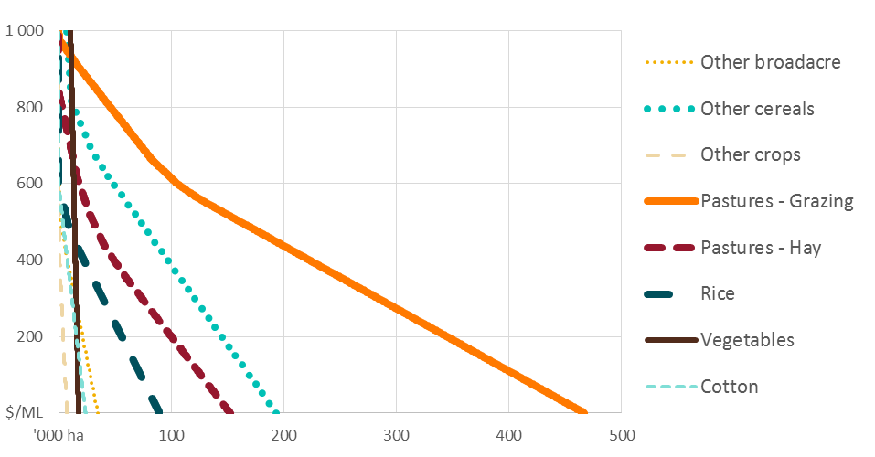

Note: Cotton, Fruits and Grapevines are exogenous and not dependent on the water allocation price.

## Water application rate

To estimate the parameters in equation 3 we fit the following regression model by irrigation activity $j pooling the data$ for each region:

$$W_{ijt}/L_{ijt}=β_{0j}^{W}+β_{1j}^{W}.P_{it}+β_{2j}^{W}R_{it}+β_{3j}^{W}Y_{it}+β_{4j}^{W}.t+β_{5j}^{W}.I (11)$$

Where $I$ is a vector of dummy variables identifying the regions $i$ (with the Murrumbidgee region omitted). Any observations with an implied application rate $W_{ijt}/L_{ijt}$ of greater than 20 ML / ha are omitted. In addition the following constraints are applied:

$$β_{1ij}^{W}<0,β_{2ij}^{W}<0,β_{3ij}^{O}>0$$

That is, water demand (for a given land area) must be downward sloping, rainfall must be a substitute for irrigation water and water demand must be increasing in response to an increase in output prices. Results are shown in Table 14.

An additional term was included for the Fruits and nuts industry in VIC Murray: an interaction between the VIC Murray region dummy and time $t$. This term was included to account for the large exogenous increase in the water application rate observed in this region, likely due to an expansion in almonds (see Hughes et al. 2016). Ideally, nuts would be included as a separate activity in the model. Data is not currently available to support this, but could become available in the future (see chapter 6).

An interaction term between the allocation price and rainfall was used for grapevines and other broadacre irrigation activities. This term accounts for non-linear responses to changes in allocation price during drought or wet years for these activities.

The parameter for allocation price did not meet the constraint for cotton, grapevines, other broadacre, other crops and pastures – hay irrigation activities (Table 14). However water use for these activities remains dependant on allocation price which is an explanatory term for irrigated land use.

Table 14 Regressions results for water application rate by irrigation activity

|  |  |  |  |  |  |  |  |  |  |  |  |  |  |
| --- | --- | --- | --- | --- | --- | --- | --- | --- | --- | --- | --- | --- | --- |
| **Industry** | **Constant** | **D0** | **D1** | **D2** | **D3** | **D4** | **D Fruits** | **Price**  **(P)** | **Output price**  **(Y)** | **Rainfall**  **(R)** | **I RP** | **Time**  **(t)** | **R2** |
| Cotton | 10.962* | -0.981 | -4.59E-15 |  | -1.377* | -0.749 |  |  |  | -0.006* |  | 0.032 | 0.60 |
|  | (0.00) | (0.11) | (0.00) | (0.00) | (0.00) | (0.15) |  |  |  | (0.00) |  | (0.65) |  |
| Grapevines | 6.982* | -1.767* | -0.741 | -0.147 | -0.330 | -0.290 |  |  |  | -0.007* | -6.67E-06 | 0.104* | 0.61 |
|  | (0.00) | (0.00) | (0.15) | (0.77) | (0.45) | (0.50) |  |  |  | (0.00) | (0.00) | (0.02) |  |
| Rice | 9.806* | -2.259* | 1.45E-15 | -2.929* | -1.191* | -1.799* |  | -0.002 | 0.012* | -0.003* |  | 0.031 | 0.52 |
|  | (0.00) | (0.00) | (0.00) | (0.00) | (0.04) | (0.00) |  | (0.20) | (0.00) | (0.02) |  | (0.70) |  |
| Fruits | 7.077* | -0.087 | 2.011* | 0.100 | 0.108 | -0.030 | 0.261* | -0.002* | 0.006 | -0.007* |  | 0.079 | 0.47 |
|  | (0.00) | (0.88) | (0.00) | (0.86) | (0.82) | (0.97) | (0.02) | (0.02) | (0.57) | (0.00) |  | (0.20) |  |
| Vegetables | 6.392* | -0.617 | 0.685* | -0.038 | 0.537 | -0.547 |  | -0.001 |  | -0.003* |  | -0.053 | 0.57 |
|  | (0.00) | (0.07) | (0.05) | (0.91) | (0.07) | (0.07) |  | (0.14) |  | (0.00) |  | (0.09) |  |
| Other broadacre | 1.054 | -1.301* | -0.647 | -1.214* | -1.590* | -1.352* |  |  | 0.028* |  | -9.63E-06 | -0.171* | 0.24 |
|  | (0.10) | (0.00) | (0.09) | (0.00) | (0.00) | (0.00) |  |  | (0.00) |  | (0.00) | (0.00) |  |
| Other cereals | 3.924* | -1.148* | -1.719* | -1.068* | -1.627* | -1.363* |  | -0.001* |  | -0.001* |  | 0.004 | 0.60 |
|  | (0.00) | (0.00) | (0.00) | (0.00) | (0.00) | (0.00) |  | (0.00) |  | (0.00) |  | (0.84) |  |
| Other crops | 4.881 | -0.836 | 0.517 | -0.269 | -0.402 | 0.155 |  |  | 0.017 | -0.001 |  | -0.339* | 0.66 |
|  | (0.21) | (0.34) | (0.57) | (0.76) | (0.63) | (0.84) |  |  | (0.58) | (0.34) |  | (0.00) |  |
| Pastures - Dairy | 3.743* | 0.852* | 1.727* | 0.527* | -0.190 | 0.687* |  | -0.001* |  | -0.002* |  | -0.022 | 0.57 |
|  | (0.00) | (0.00) | (0.00) | (0.03) | (0.36) | (0.00) |  | (0.01) |  | (0.00) |  | (0.34) |  |
| Pastures - Hay | 4.103* | -0.559* | 0.968* | -0.537* | -0.616* | -0.543* |  |  |  | -0.002* |  | 0.028 | 0.55 |
|  | (0.00) | (0.02) | (0.00) | (0.02) | (0.00) | (0.01) |  |  |  | (0.00) |  | (0.14) |  |

Note: **D0** = dummy for VIC Goulburn-Broken, **D1** = dummy for SA Murray, **D2** = dummy for VIC Loddon-Campaspe, **D3** = dummy for NSW Murray, **D4** = dummy for VIC Murray. **D Fruits** = interaction term with time for Fruits in the VIC Murray region. **RP** = interaction term for rainfall and price for Grapevines and Other broadacre. * denotes significance at the 95% level

The water application rate is combined with land use to estimate the corresponding total water use by region and by irrigation activity (equation 4). Figure 4 shows the demand curve for water across all regions for each irrigation activity (holding other predictors at sample average values). As would be expected, rice, other broadacre, other crops and pastures – hay are observed to be relatively price elastic while fruits, grapevines and vegetables are relatively price inelastic.

Figure 4 Total water use as a function of water allocation price, by irrigation activity

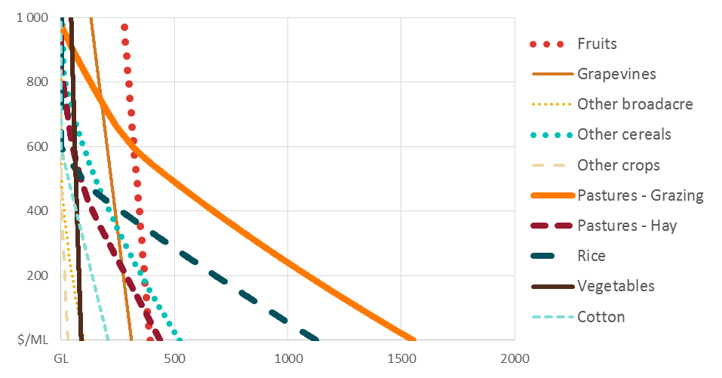

Figure 5 shows the corresponding demand functions for water by region. NSW Murrumbidgee water demand is relatively elastic given the high proportion of Rice, while SA Murray is relatively inelastic given the high proportion of horticultural activity.

Figure 5 Total water use as a function of water allocation price, by region

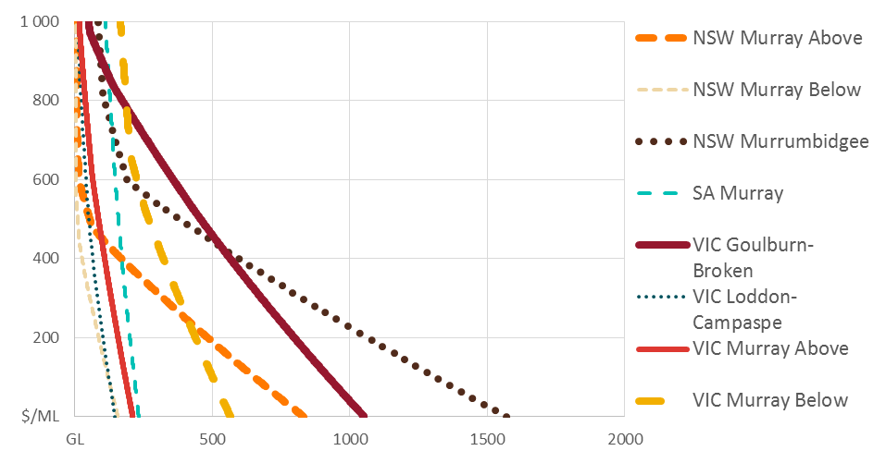

## Water demand in the NSW Lower Darling

Given the relatively small amount of irrigation activity in the NSW Lower-Darling region, and problems of measurement error in the available data (see Hughes, et al. 2016) reliable estimates could not be obtained using the models outlined above. Instead a single aggregate demand curve was fit for NSW Lower Darling region. The specification for this is follows Hughes et al. (2016) (equation 12). The resulting model estimation is shown in Table 15.

Table Regressions results for water allocation demand, NSW Lower Darling

|  |  |  |  |
| --- | --- | --- | --- |
| **Dependant variable** | **Constant** | **Allocation water use (A)** | **Rainfall (R)** |
| log (Price) | 4.52 | -5.32E-06 | -4.01E-04 |

## Other water

Net other water is econometrically estimated according to equation 13:

$${\hat{O}}_{it}=β_{0i}^{O}+β_{1i}^{O}.P_{it}+β_{2i}^{O}R_{it}+β_{3i}^{O}.t+e_{it} (13)$$

$$β_{1i}^{O}>0$$

$$O_{it}={\hat{W}}_{it}-(A_{it}+Δ_{it})$$

where $e_{it}$ is the regression residual term and ${\hat{W}}_{it}$ is the model predicted water use level for region *i*. Within the model the residual term in this equation is included as a region and time specific constant. This approach is a pragmatic way of maximising the within sample fit of the model for the baseline scenario (in the absence of a more formal structural estimation method). Regression results are presented in Table 16.

Table 16 Regressions results for other water use, by region

|  |  |  |  |  |  |
| --- | --- | --- | --- | --- | --- |
| **Region** | **Constant** | **Price (P)** | **Rainfall (R)** | **Time (t)** | $R^{2}$ |
| VIC Murray Above | -555842.2* | 492.6* | 346.2* | 12864.1* | 0.79 |
|  | (0.00) | (0.00) | (0.01) | (0.01) |  |
| VIC Murray Below | -765222.8* | 626.5* | 757.7* | 50379.5* | 0.84 |
|  | (0.00) | (0.01) | (0.01) | (0.00) |  |
| VIC Goulburn-Broken | -240955.9 | 302.3 | 147.8 | 28623.6* | 0.64 |
|  | (0.08) | (0.06) | (0.48) | (0.00) |  |
| VIC Loddon-Campaspe | 84946.0* |  | -67.9 | -48.6 | 0.20 |
|  | (0.00) |  | (0.12) | (0.98) |  |
| NSW Murrumbidgee | 717593.5 | 77.8 | -1488.4 | -4215.9 | 0.38 |
|  | (0.06) | (0.88) | (0.06) | (0.85) |  |
| NSW Murray Above | -261218.7 | 536.8 | 499.2 | -5896.9 | 0.23 |
|  | (0.35) | (0.15) | (0.37) | (0.67) |  |
| NSW Murray Below | -334738.2* | 351.0* | 326.4 | -1433.9 | 0.58 |
|  | (0.00) | (0.01) | (0.07) | (0.73) |  |
| SA Murray | -371002.2* | 273.6* | 213.7 | 12470.0* | 0.78 |
|  | (0.00) | (0.00) | (0.11) | (0.00) |  |

Note: * denotes significance at the 95% level

# Validation

This chapter presents results for the model baseline scenario. In this scenario, model inputs such as water availability (water allocations, entitlements, carry-over), climate (rainfall) and commodity prices are based on historical conditions as defined by our dataset. Note that this scenario includes the effect on water availability of Commonwealth water entitlement recovery associated with the Basin Plan.

As discussed, model estimation uses the time period 2005–06 to 2015–16. However data is also available for all exogenous variables (water availability, climate and commodity prices) for all years 2002–03 to 2016–17. Therefore, model results are presented for the full period 2002–03 to 2016–17, with the years 2002–03 to 2004–05 and 2016–17 being out-of-sample predictions. Note that data is not available on perennial land areas for out-of-sample years, so these are assumed equal to the nearest available year.

## Water allocation prices

Model results for water allocation prices accurately capture historical variation over time as well as differences between regions due to trade constraints. For example, the model is able to recreate higher prices in Northern Victoria and lower prices in NSW Lower Darling during drought years (Figure 6). Out of sample results for 2002–03 to 2004–05 and 2016–17 are indicated by the grey shaded bands in the figure.

Figure 6 Actual and modelled water allocation prices, by trading zone, 2002–03 to 2016–17

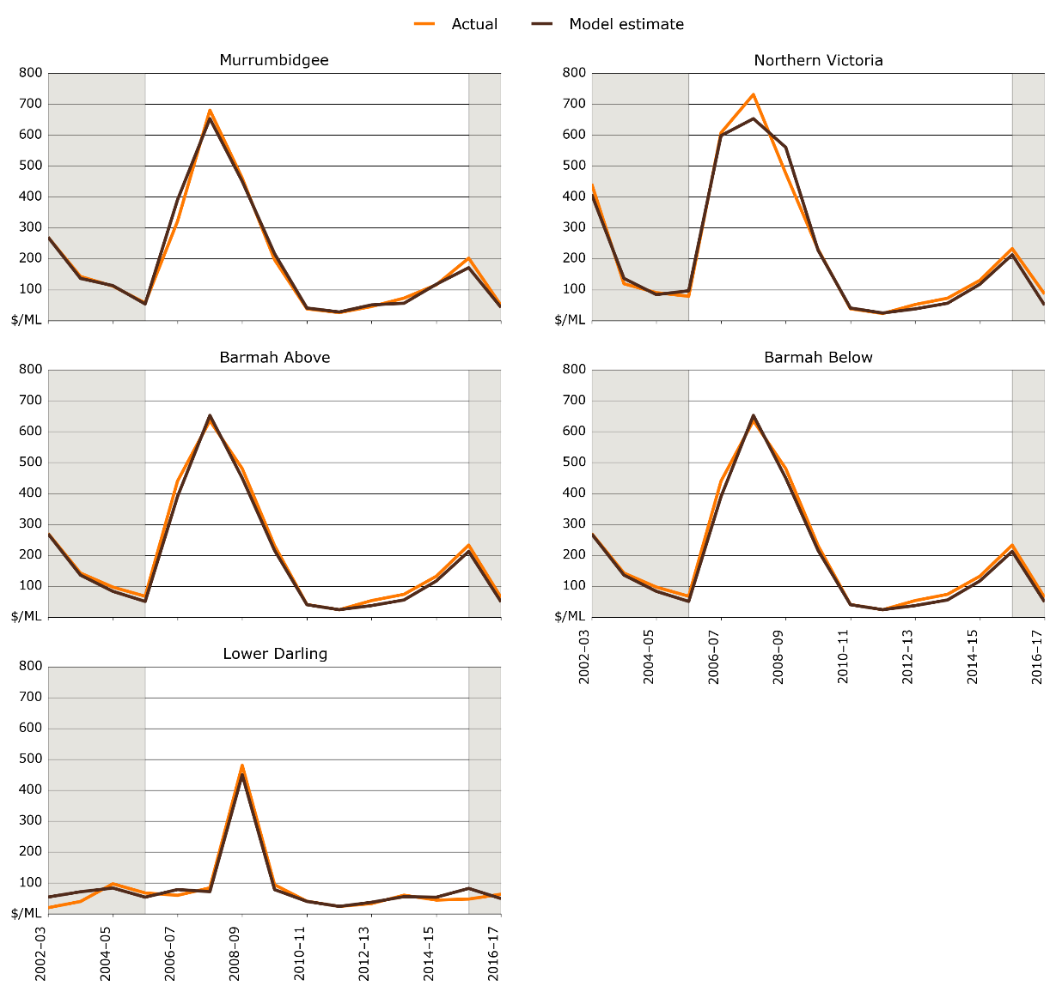  
Note: Barmah above is the model trading zone 1; Barmah below is model trading zone 5.

## Net trade flows

Replicating historical net trade flows is challenging given the model estimation does not include them as target variable. Further the modelled inter-regional trade flows are sensitive to the assumed trade constraints. While these have been specified to emulate historical trading conditions as much as possible, representing these constraints within the model is difficult given the annual time scale. As noted in previous research (Hughes et al.2016), limits can vary across and within years depending on river operation decisions, and changes in trading rules.

Notwithstanding these issues, the model does a reasonable job of matching historical trading patterns for most zones, including for example water exports from the Murrumbidgee and imports into the below Barmah Murray zone (i.e., SA Murray) during the drought (Figure 7).

Figure 7 Actual and modelled net inter-zonal trade, by trading zone, 2002–03 to 2016–17

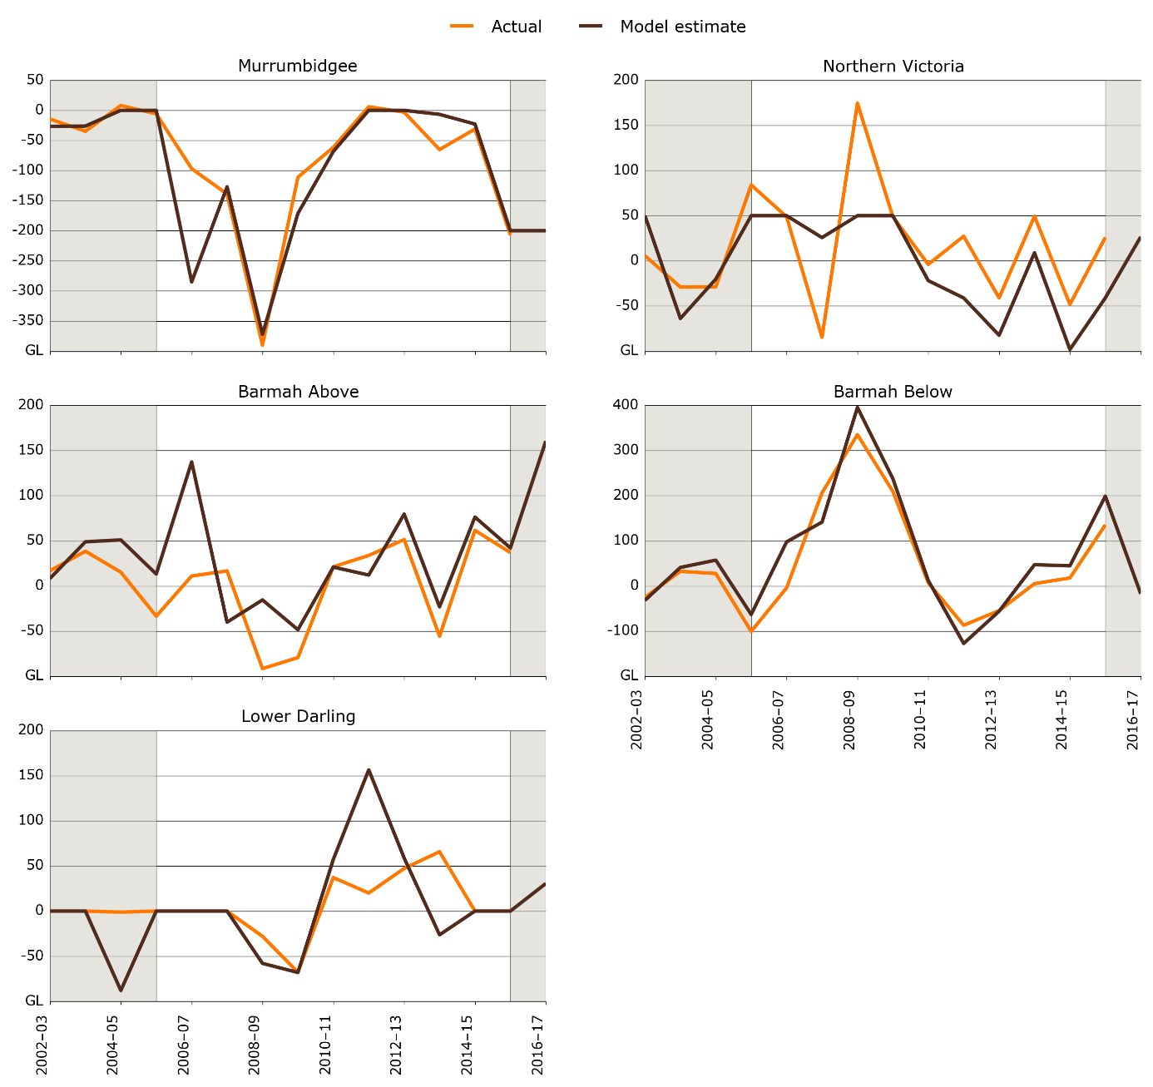  
Note: Barmah above is the model trading zone 1; Barmah below is model trading zone 5

## Irrigation activity

Model results for total water use and land use are shown in Figure 8 and Figure 9. Trends in irrigated land use are reflected in total water use and the model is able to accurately recreate key historical trends. For example, a decrease in irrigated land use and water use during drought years, and an increase in irrigated land use for most years between 2008–09 and 2012–13.

Out of sample results, indicated by the grey shaded bands in each figure. While the out-of-sample performance is reasonable, the model tends to overestimate water use in South Australia and Victoria during the period 2002–03 to 2004–05. However, it is worth noting that for the years 2002–03 to 2004–05 ABS data was only available for Statistical Division (SD) region level (rather than the NRM regions that applied from 2005–06). This creates something of a structural break in the data which could contribute to this poor performance. This data issue could be addressed in future research (see chapter 6).

Figure 8 Actual and modelled total water use, by region, 2002–03 to 2016–17

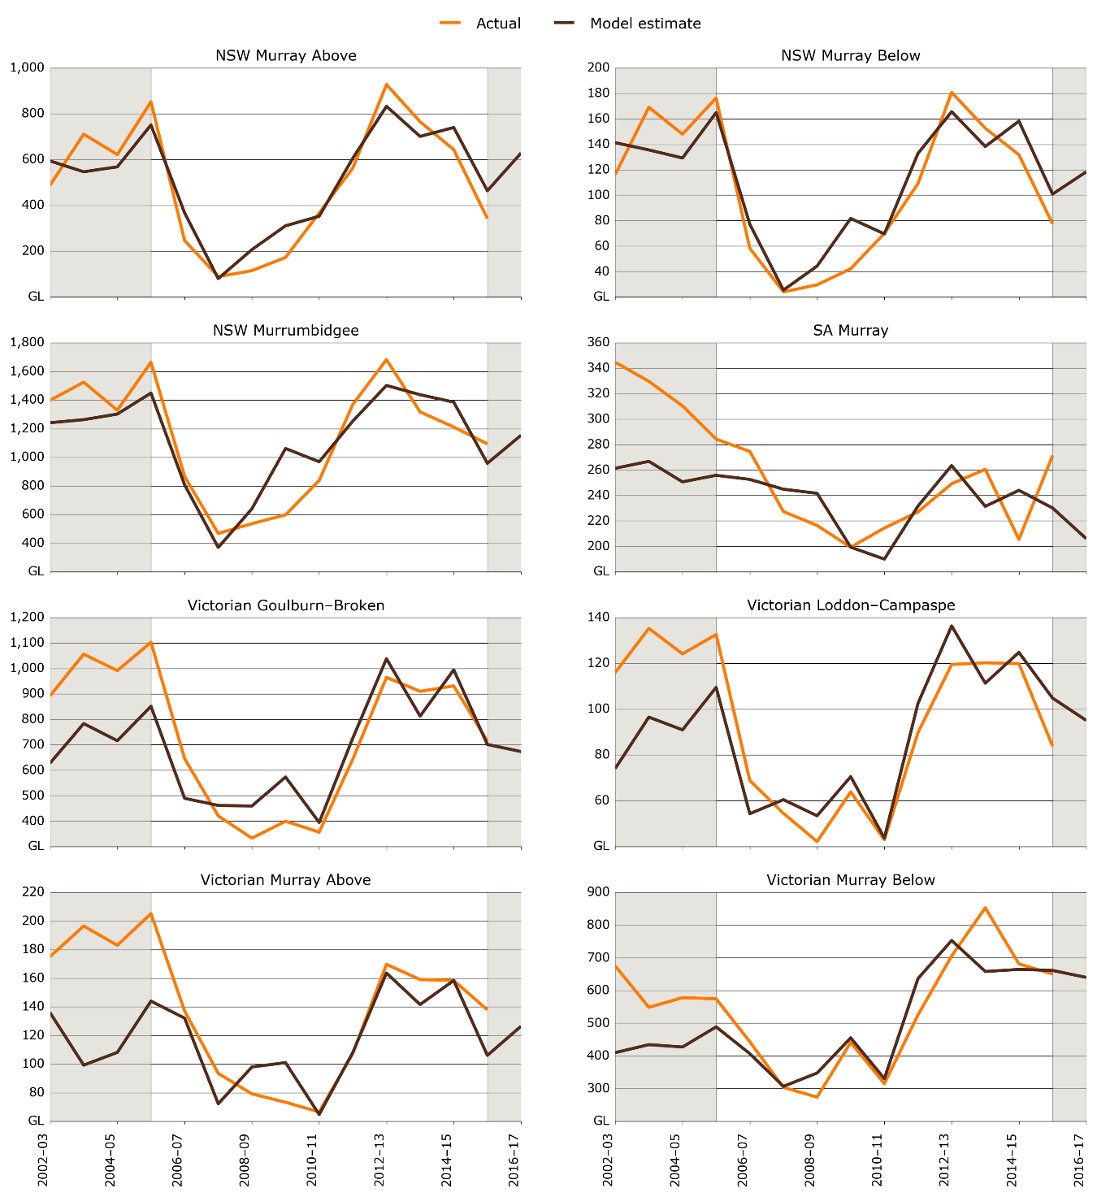

Figure 9 Actual and modelled total irrigated land use, by region, 2002–03 to 2016–17

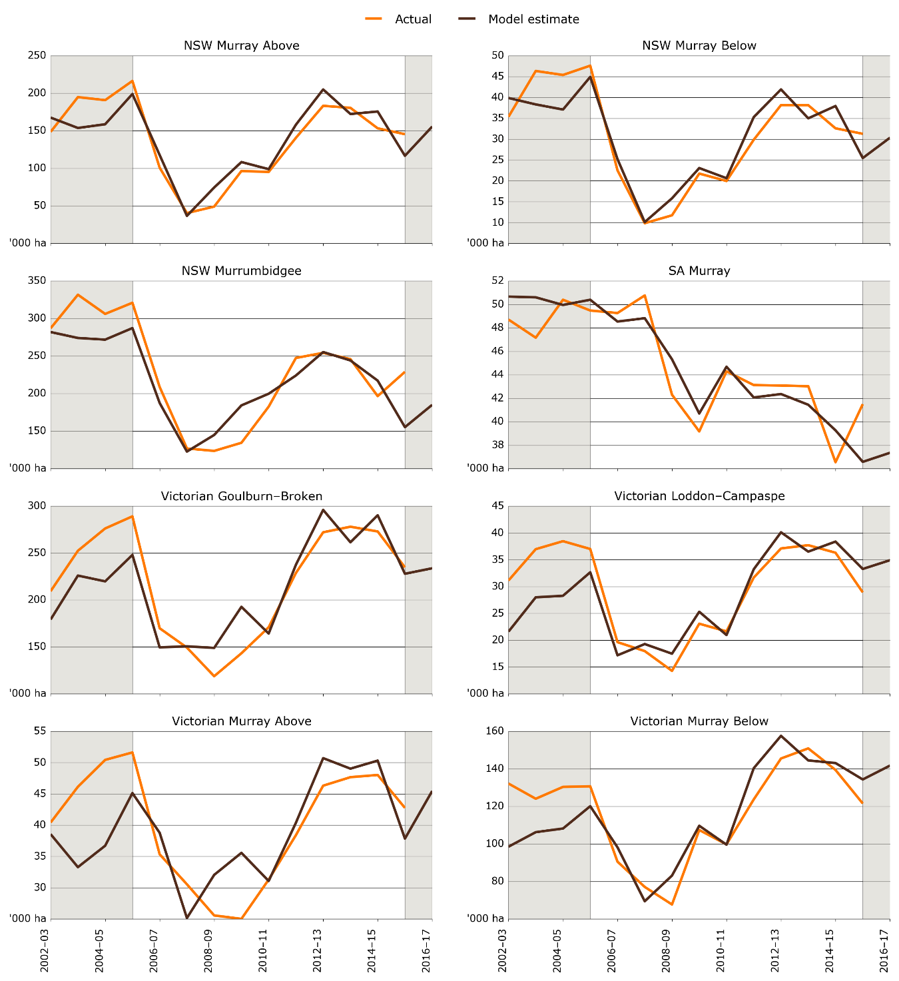

## Entitlement prices

As discussed, entitlement prices are estimated as the discounted value of allocations, based on average allocation prices and percentages over the full model period. In order to predict current water entitlement prices, the model baseline is adjusted such that current levels of environmental water recovery are applied from the beginning of the period, to simulate likely allocation prices going forward.

Table 17 shows the estimated entitlement prices for different entitlement types compared with market prices as of June 2017. Figure 10 provides a scatter of actual vs predicted entitlement. The models simple methodology for estimating entitlement prices is able to explain much of the variation in entitlement prices between regions and reliability types. However, it should be noted that the ability of the model to predict changes in entitlement prices over time has not been tested. In practice, predicting future changes in entitlement prices is difficult, given these depend on market expectations of future water supply and demand conditions (including potential changes in irrigated land use, climate and water demand).

Table Actual and modelled entitlement prices, as at June 2016

|  |  |  |
| --- | --- | --- |
| **Entitlement type** | **Model estimate ($/ML)** | **Market price – June 2017 ($/ML)** |
| NSW Lower Darling General | 1104 |  |
| NSW Lower Darling High | 1654 | 1600 |
| NSW Murray General | 880 | 1241 |
| NSW Murray High | 3204 | 3228 |
| NSW Murrumbidgee General | 1188 | 1468 |
| NSW Murrumbidgee High | 3631 | 3500 |
| SA Murray High | 2518 | 3029 |
| VIC Campaspe High | 1675 | 2346 |
| VIC Goulburn High | 2723 | 2567 |
| VIC Loddon High | 1613 | 1862 |
| VIC Murray Above High | 2944 | 2629 |
| VIC Murray Above Low | 181 | 348 |
| VIC Murray Below High | 3024 | 2781 |
| VIC Murray Below Low | 201 | 307 |
| NSW Murray Above High | 3165 |  |
| NSW Murray Above General | 867 |  |
| NSW Murray Below High | 3244 |  |
| NSW Murray Below Low | 893 |  |

Note: Historical prices sourced from Marsden Jacobs and Associates (MJA) data provided to the Department of Agriculture and Water Resources. Estimates for NSW Murray entitlement prices are calculated as an average of NSW Murray Above and NSW Murray Below prices.

Figure Modelled entitlement prices compared to actual prices

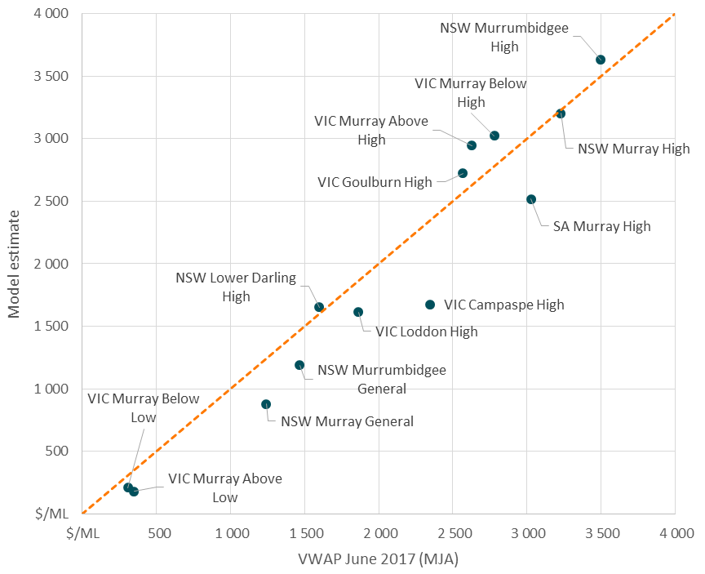

## Performance of the baseline scenario

The correlation between model estimates and actual data for key outputs, measured by the R-squared, is shown in Table 18. Results are presented across regions and irrigation activities for the water allocation price, and irrigated area and water use.

The in-sample results presented in Table 18 correspond to the sample used for econometric estimation: 2005–06 to 2015–16 or 11 years. The out of sample results correspond to the periods 2002–03 to 2004–05 and 2016–17 (4 years) and the full sample refers to the complete modelling period from 2002–03 to 2016–17 (15 years). In general the R-squared values in Table 18 suggest that a high degree of variance in actual data can be explained by the ABARES water trade model for a range of outputs.

Table  Correlation between model estimates and actual data for key modelling outputs

|  |  |  |  |
| --- | --- | --- | --- |
| **Variable** | **R-squared** | | |
|  | **In-sample** | **Out-of-sample** | **Full sample** |
| Water allocation price (by region and year) | 0.98 | 0.97 | 0.98 |
| Land use (by region, irrigation activity and year) | 0.96 |  |  |
| Land use (by region and year) | 0.96 | 0.96 | 0.96 |
| Water use (by region, irrigation activity and year) | 0.92 |  |  |
| Water use (by region and year) | 0.93 | 0.89 | 0.94 |

# Conclusions

This paper presents an economic model of water trade and irrigation activity within the southern Murray-Darling Basin (sMDB). This model combines two previously competing approaches to estimating water demand: econometric analysis of water market data and bio-physical optimisation models. The model is able to simulate the water market prices and water trade flows across regions taking into account constraints on inter-regional allocation trade. The model parameters are estimated econometrically given historical data on water market outcomes and irrigation water demand.

The data-driven approach adopted for this model has a number of advantages:

* The model provides a wide range of outputs including both water market outcomes (prices of allocations and entitlements) and irrigation sector outcomes (water and land use)
* Validation tests demonstrate the model can accurately simulate historical data both within and out-of-sample.
* Water demand responses broadly conform to expert expectations and literature; for example, more elastic responses in broadacre activities and more inelastic responses in horticulture.

The approach adopted in this study also has some limitations. Firstly, the data used in this study are subject to measurement error, given changes within statistical collections across time and differences between data sources. Secondly, given water demand is estimated in reduced form (rather than from a model of farm production) the model is not well suited to extrapolating to price levels or climate conditions significantly outside of historically observed ranges.

Third, the model is short-run in nature simulating annual changes in water demand holding capital investment in the irrigation sector exogenous. As such, the model is not suitable for predicting longer-term structural changes in the industry (such as future changes in the mix of annual and perennial crops), although the model can be used to explore and assess user defined scenarios around these issues (as discussed below).

## Future model development

One direction for future work would be to improve the dataset, particularly the irrigation water and land use data. ABARES has recently established an agreement with the ABS (in accordance with ABS legislative provisions) that provides access to unit-record (farm level) data from ABS agricultural census and surveys. This data access provides a number of exciting possibilities: including generation of more accurate catchment level statistics, addition of new industry categories (such as nuts), and even farm level water demand modelling.

A second direction for future work would be to improve the estimation methods, in particular to adopt a structural estimation approach, where all model equations are simultaneously fit to the data (as opposed to the equation by equation OLS approach currently employed).

Third, there are a number of features that could be added to the model some of which are currently under development:

* Output supply responses: predicting irrigation output supply or production (e.g., GVIAP) as a function of water prices, rainfall and output prices.
* Carryover: predicting user carryover behaviour as a function of water prices, rainfall and output prices.
* Extending the model to other regions (such as the northern MDB) and industries (such as nuts) depending on data availability.
* Diversions: including estimates of water diversions by catchment, as a function of farm regional water use, prices and rainfall.

## Potential applications

The model has a number of potential applications including:

* **Past and future water policy changes:** the model could be used to examine the effects of historical water policy changes on water markets and the irrigation sector – such as environmental water recovery associated with the Murray-Darling Basin plan.
* **Water availability:** the model could examine the implications of changes in water availability associated with climate variability and change.
* **Inter-regional water trade constraints:** the model could be used to simulate the effects of changes to interregional water trade constraints on water markets – for example the Murrumbidgee IVT rule.
* **Changes in perennial plantings:** the model could be used to simulate the effects of future increases or changes in the mix and location of perennial plantings. For example the model could evaluate the implications of expanded investment in nuts in the Victorian Murray region.
* **Annual projections:** the model could also be used to project future allocation prices and trade flows given assumptions on future allocation and rainfall levels.

# References

ABARES 2015, Australian water markets report 2013–14, Australian Bureau of Agricultural and Resource Economics and Sciences, Canberra, available at <http://www.agriculture.gov.au/abares/publications/display?url=http://143.188.17.20/anrdl/DAFFService/display.php%3Ffid%3Dpb_awmr_d9aawr20151211.xml>

ABARES 2016a, Catchment Scale Land Use of Australia - Update May 2016, ABARES, Canberra, available at <http://www.agriculture.gov.au/abares/aclump/land-use/data-download>

ABARES 2016b, Australian Water Markets Report 2014–15, Australian Bureau of Agricultural and Resources Economics and Sciences, Canberra, available at <http://www.agriculture.gov.au/abares/publications/display?url=http://143.188.17.20/anrdl/DAFFService/display.php%3Ffid%3Dpb_awmr_d9aawr20161202.xml>

ABARES 2017a, ABARES agricultural commodities series, Australian Bureau of Agricultural and Resource Economics and Sciences, Canberra, available at <http://www.agriculture.gov.au/abares/publications/display?url=http://143.188.17.20/anrdl/DAFFService/display.php%3Ffid%3Dpb_agcomd9abcc20170307_0S6mp.xml>

ABARES 2017b, Australian Water Markets Report 2015–16, Australian Bureau of Agricultural and Resources Economics and Sciences, Canberra, available at <http://www.agriculture.gov.au/abares/research-topics/water/aust-water-markets-reports>

ABS 2010, Australian wine and grape industry 2010, cat. no. 1329.0, Australian Bureau of Statistics, Canberra, available at <http://www.abs.gov.au/ausstats/abs@.nsf/mf/1329.0>

ABS 2015, Gross value of irrigated agricultural production 2013–14, cat. no. 4610.0, Australian Bureau of Statistics, Canberra, available at <http://www.abs.gov.au/ausstats/abs@.nsf/mf/4610.0.55.008>

ABS 2016a, Agricultural commodities Australia, cat. no. 7121.0, Australian Bureau of Statistics, Canberra, available at <http://www.abs.gov.au/ausstats/abs@.nsf/mf/7121.0>

ABS 2016b, Water use on Australian farms 2014–15, cat. no. 4618.0, Australian Bureau of Statistics, Canberra, available at <http://www.abs.gov.au/ausstats/abs@.nsf/mf/4618.0>

Adamson, D., Loch, A., Schwabe, K., 2017. Adaptation responses to increasing drought frequency. Australian Journal of Agricultural and Resource Economics, 61(3): 385-403

Adamson, D., Mallawaarachchi, T. and Quiggin, J, 2007, Water use and salinity in the Murray–Darling Basin: A state-contingent model. Australian Journal of Agricultural and Resource Economics, 51: 263–281.

Aither 2016a, Supply-side drivers of water allocation prices, Aither, Canberra, available at <http://www.aither.com.au/insights/published/>

Aither 2016b, Contemporary trends and drivers of irrigation in the southern Murray-Darling Basin, report for RIRDC National Rural Issues, Rural Industries Research and Development Corporation, Canberra, available at <http://www.aither.com.au/insights/published/>

Apples, D, Douglas, R and Dwyer, G 2004, Responsiveness of Demand for Irrigation Water: A Focus on the Southern Murray–Darling Basin, Productivity Commission Staff Paper.

Bjornlund, H and Rossini, P 2005, ‘Fundamentals determining prices and activities in the market for water allocations’, International Journal of Water Resource Development, vol. 21, pp. 355–369.

BOM 2017, High resolution monthly and multi-monthly rainfall gridded datasets from 1900 onwards, Bureau of Meteorology, available at <http://www.bom.gov.au/jsp/awap/rain/index.jsp>

Brennan, D 2006, ‘Water policy reform in Australia: lessons from the Victorian seasonal water market’, Australian Journal of Agricultural and Resource Economics, vol. 50, no. 3, pp. 403–23.

Brennan, D 2010, Water prices in the lower Murray market: the effect of physical trading constraints, climate change and the spatial pattern of buyback, unpublished manuscript.

Caboche T, Shafron W, Gunning-Trant C, Lubulwa M, Martin P, 2013, Australian wine grapes: financial and business performance of wine grape growers 2011–12, ABARES research report (13.14), Canberra, December, available at <http://www.agriculture.gov.au/abares/publications/display?url=http://143.188.17.20/anrdl/DAFFService/display.php?fid=pb_awgfbpd9aasw20131219.xml>

CEWO 2017, Commonwealth Environmental Water Office Publications and resources, Commonwealth Environmental Water Office, available at <http://www.environment.gov.au/water/cewo/publications>

CSIRO & BOM 2015, Climate Change in Australia Information for Australia’s Natural Resource Management Regions: Technical Report, CSIRO and Bureau of Meteorology, Australia, available at <https://www.climatechangeinaustralia.gov.au/media/ccia/2.1.6/cms_page_media/168/CCIA_2015_NRM_TechnicalReport_WEB.pdf>

CSIRO 2008, Murray–Darling Basin Sustainable Yields Project, Commonwealth Scientific and Industrial Research Organisation, available at <https://www.csiro.au/en/Research/LWF/Areas/Water-resources/Assessing-water-resources/Sustainable-yields/MurrayDarlingBasin>

CSIRO 2012, ‘Climate and water availability in south-eastern Australia: a synthesis of findings from Phase 2 of the South Eastern Australian Climate Initiative (SEACI)’, Commonwealth Scientific and Industrial Research Organisation, [seaci.org/publications/documents/SEACI-2Reports/SEACI_Phase2_SynthesisReport.pdf](http://www.seaci.org/publications/documents/SEACI-2Reports/SEACI_Phase2_SynthesisReport.pdf).

DELWP 2017, Victorian water register, Victoria Department of Environment, Land, Water and Planning, available at: <http://waterregister.vic.gov.au/>

DEWNR 2017, South Australia water allocations and announcements, South Australia Department of Environment, Water and Natural Resources, available at: <http://www.environment.sa.gov.au/managing-natural-resources/river-murray/water-allocation-and-carryover/water-allocations-and-announcements>

Doole, G J and Marsh, D K, 2014, Methodological limitations in the evaluation of policies to reduce nitrate leaching from New Zealand agriculture, Australian Journal of Agricultural and Resource Economics 58, 78–89

DPI 2017a, Historic available water determination data, New South Wales Department of Primary Industries – Water, Sydney, available at <http://www.water.nsw.gov.au/water-management/water-availability/water-accounting>

DPI 2017b, Water accounting, New South Wales Department of Primary Industries – Water, Sydney, available at: <http://www.water.nsw.gov.au/water-management/water-availability/water-accounting>

Grafton, R and Jiang, Q 2011, ‘Economic Effects of Water Recovery on Irrigated Agriculture in the Murray–Darling Basin’, The Australian Journal of Agricultural and Resource Economics, Vol. 55, pp. 1–13.

Hafi, A, Thorpe, S and Foster, A 2009, ‘The impact of climate change on the irrigated agricultural industries in the Murray–Darling Basin’, ABARE Conference Paper 09.03, presented at the Australian Agricultural and Resource Economics Society Conference, Cairns, Queensland, 11–13 February.

Hall, N, Poulter, D and Curtotti, R 1994, ABARE Model of Irrigation Farming in the Southern Murray–Darling Basin, ABARE Research Report 94.4, Canberra.

Heckelei, T and Wolff, H 2003, Estimation of constrained optimisation models for agricultural supply analysis based on generalised maximum entropy, European Review of Agricultural Economics, Volume 30, Issue 1, 1 March 2003, Pages 27–50, [doi.org/10.1093/erae/30.1.27](https://doi.org/10.1093/erae/30.1.27)

Hughes, N, Gupta, M & Rathakumar, K 2016, *Lessons from the water market: the southern Murray–Darling Basin water allocation market 2000–16*, ABARES research report 16.12, Canberra, December, available at <http://www.agriculture.gov.au/abares/publications/display?url=http://143.188.17.20/anrdl/DAFFService/display.php?fid=pb_smdwm_d9aawr20161202.xml>.

Murray Irrigation 2016, Murray Irrigation water exchange, Murray Irrigation, Deniliquin, Australia, available at <http://www.murrayirrigation.com.au/water/water-trade/water-exchange/>

NVRM 2017, Seasonal determinations, Northern Victoria Resource Manager, Tatura, Victoria, available at: <http://nvrm.net.au/seasonal-determinations>

Qureshi, M, Ranjan, R and Qureshi, S 2010, ‘An empirical assessment of the value of irrigation water: the case study of Murrumbidgee catchment’, The Australian Journal of Agricultural resource economics, vol. 52. pp. 37–55.

Qureshi, M, Whitten, M, Mainuddin, M, Marvanek, S & Elmahdi, A 2013, A biophysical and economic model of agriculture and water in the Murray-Darling Basin, Australia, Environmental Modelling & Software, Volume 41, Pages 98-106.

Water Exchange, Water Exchange, Ruralco Water. (now at: <https://www.ruralco.com.au>)

Waterfind 2016, Waterfind exchange, Waterfind Australia, available at <https://www.waterfind.com.au/>

WaterNSW 2017, NSW Water Availability Reports, WaterNSW, Sydney, available at <http://www.waternsw.com.au/customer-service/news/availability>

Wheeler, S, Bjornlund, H, Shanahan, M and Zuo, A 2008, ‘Price elasticity of water allocations demand in the Goulburn–Murray irrigation district’, The Australian Journal of Agricultural and and Resource Economics, vol. 54, pp. 119–136.

Appendix A: Dataset construction

This appendix details the construction of various datasets used in this report. Table A1 summarises some of the key datasets and their sources.

Table A Data variables and sources

|  |  |  |  |  |
| --- | --- | --- | --- | --- |
| Variable | Description | Units | Time period | Source |
| Rainfall | Average rainfall by region and year | mm | 2002–03 to 2016–17 | BOM |
| End-of-period water allocation percentage | Allocation percentages by entitlement type, region and year | % | 2002–03 to 2016–17 | State governments |
| Carryover | Carryover percentages by entitlement type, region and year | % | 2002–03 to 2016–17 | State governments, CEWO |
| Water entitlement volume | Entitlement volume by type, region and year | ML | 2002–03 to 2016–17 | State governments, DAWR |
| Net inter-regional water allocation trade | Allocation trade between water trade model regions | ML | 2002–03 to 2015–16 | MDBA |
| Water allocation price | Allocation trade prices by region and year | $/ML | 2002–03 to 2016–17 | State water registries/ water exchanges |
| Water use | Total water use by region, industry and year | ML | 2005–06 to 2015–16 | ABS |
| Land use | Total land use by region, industry and year | HA | 2005–06 to 2015–16 | ABS |
| Commodity prices | Gross unit value or price indices for activities by industry and year | $/ton or indexed value | 2002–03 to 2016–17 | ABARES |
| Non allocation water use | Primarily groundwater and unregulated surface water use by region and year | ML | 2002–03 to 2015–16 | ABS |

## Rainfall

Rainfall estimates are based on average annual rainfall (in millimetres) across national land use and management (NLUM) and catchment-scale land use (CLUM) irrigated areas in each region in the water trade model. Figure A1 shows the average rainfall index (based on irrigated area in each region) across the entire sMDB. The drought years in the sMDB are 2001–02, 2002–03, 2005–06, 2006–07, 2007–08 and 2008–09. The wet years are 2010–11 and 2011–12, which also led to higher storage volumes and allocation announcements in 2012–13 and 2013–14, despite relatively lower rainfall.

#### **Notes on construction**

* The irrigated areas are defined as those 5 kilometre grid cells where at least 10 per cent of the cell contained irrigated land use in at least one of the NLUM (2000–01, 2005–06 or 2010–11) or 2015–16 CLUM areas. The concordance between rainfall, irrigated area and water regions is shown for 2015–16 in Map A1.

#### Sources

* Rainfall data available from the [Bureau of Meteorology’s latest rainfall maps](http://www.bom.gov.au/jsp/awap/rain/index.jsp?colour=colour&time=latest&step=0&map=totals&period=12month&area=nat) (BOM 2017).
* NLUM/CLUM data available from [ABARES land use data page](http://www.agriculture.gov.au/abares/aclump/land-use/data-download) (ABARES 2016a).
* ABARES water regions based on CSIRO Murray-Darling Basin Sustainable Yields Project boundaries (CSIRO 2008), adjusted for trade rules and the Barmah Choke (available on request).

Figure A Average rainfall index across the sMDB, 2000–01 to 2015–16

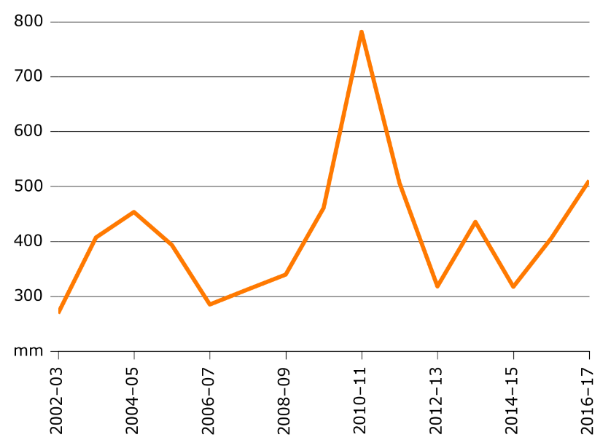

Map A Rainfall, irrigated areas and water regions, 2015–16

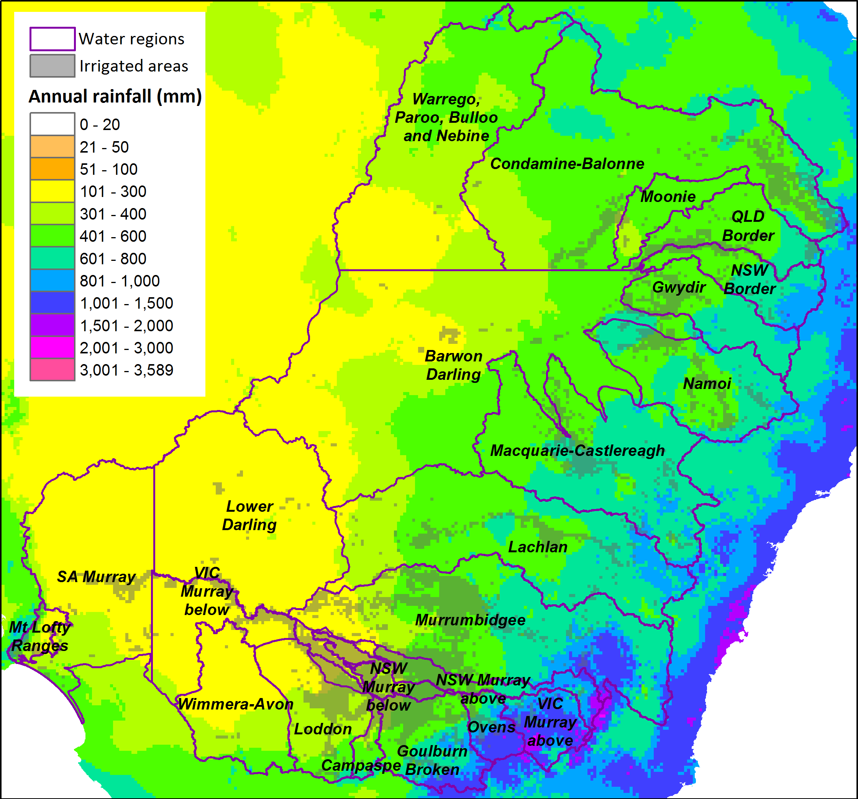

## Allocations and carryover

The allocations dataset used for this report was previously prepared for Hughes, Gupta & Rathakumar (2016) on a daily time step from 1 July 2000 to 30 June 2017.

#### Data for the Barmah Choke

Entitlement volumes and environmental purchases for the NSW Murray and VIC Murray regions are apportioned above and below the Barmah Choke using the proportion of entitlements on issue (Table A2).

Table A2 Proportion of entitlements on issue above and below the Barmah choke, by type

|  |  |
| --- | --- |
| Entitlement type | Proportion |
| NSW Murray Above General | 0.78 |
| NSW Murray Below General | 0.22 |
| NSW Murray Above High | 0.14 |
| NSW Murray Below High | 0.86 |
| VIC Murray Above High | 0.32 |
| VIC Murray Below High | 0.68 |
| VIC Murray Above Low | 0.32 |
| VIC Murray Below Low | 0.68 |

#### Sources

* Entitlements, allocations and carryover:
  + NSW Department of Primary Industries - Water (DPI 2017b) water accounting reports,
  + NSW Department of Primary Industries - Water (DPI 2016) Personal Communication, Dan Berry,
  + Water NSW (2017) Water availability reports,
  + Victorian water register (DELWP 2016),
  + Northern Victorian Resource Manager (2016),
  + Goulburn-Murray Water (2016) Personal Communication, Guy Ortlipp,
  + South Australian Department of Environment Water and Natural Resources (2016) Water allocations
* Environmental water:
  + Commonwealth Environmental Water Office (CEWO) Annual carryover reports and website (CEWO 2017),
  + Department of Agriculture and Water Resources (DAWR) Volumes of water entitlements secured by the Commonwealth in the MDB.

## Water allocation prices

Monthly water prices were obtained for the Murray, Murrumbidgee, Northern Victoria and Lower-Darling trading zones for the period July 2000 to June 2017. Earlier estimates – in particular before 2007–08 – are sourced from various water exchanges. Annual prices, unless otherwise specified, are calculated as the average of monthly prices. Further detail on the construction of this dataset can be found in Hughes, Gupta & Rathakumar (2016).

## ABS data

Water and land use by region, industry and year is taken from ABS agricultural data. The data was first constructed as a time series using annual ABS Agricultural Commodities and Water Use on Australian Farms NRM level data. The ABS data was apportioned from NRM regions to the regions used in the water trade model using geographical data sourced from:

* ABARES water catchment regions based on CSIRO’s Murray-Darling Basin Sustainable Yields Project, adjusted for trade rules and the Barmah Choke,
* Irrigation areas from the NLUM and CLUM datasets,
* Victorian Department of Land, Water and Planning (VIC DELWP) trade zones,
* ABS natural resource management (NRM) regions.

### **Homogenising ABS industry definitions**

* ABS agricultural industry definitions have changed over time. ABS agricultural industry data was first homogenised across years using the definitions specified in Table A.
* For use in the water trade model the homogenised time series data was grouped into the irrigation activities listed in Table A3. A detailed breakdown for matching irrigation activities for each ABS survey is listed in Table A4.

Table A ABARES industry labels and groupings for water trade model

|  |  |
| --- | --- |
| ABS NRM data industry classification | Water trade model activity |
| Cotton | Cotton |
| Fruit trees, nut trees, plantation or berry fruits | Fruits |
| Grapevines | Grapevines |
| Nurseries, cut flowers and cultivated turf | Other crops |
| Other broadacre crops | Other broadacre |
| Other cereals for grain or seed | Other cereals |
| Other crops n.e.c. | Other crops |
| Pastures and cereal for grazing | Pastures - Dairy |
| Pastures and cereal for hay | Pastures - Hay |
| Pastures and cereal for silage | Pastures - Hay |
| Rice | Rice |
| Sugar cane | Sugar cane (excluded) |
| Vegetables for human consumption | Vegetables |

Note: Alloc

Table A4 ABS agricultural industry definitions and ABARES labels

|  |  |
| --- | --- |
| 2011-12 ABS industry definitions | ABARES labels |
| Pastures (incl lucerne) and cereal crops used for grazing or fed off | Pastures and cereal for grazing |
| Pastures (incl lucerne) and cereal crops cut for hay | Pastures and cereal for hay |
| Pastures (incl lucerne) and cereal crops cut for silage | Pastures and cereal for silage |
| Rice | Rice |
| Other cereals for grain or seed | Other cereals for grain or seed |
| Cotton | Cotton |
| Sugar cane | Sugar cane |
| Other broadacre crops | Other broadacre crops |
| Fruit trees nut trees plantation and berry fruits | Fruit trees, nut trees, plantation or berry fruits |
| Vegetables for human consumption | Vegetables for human consumption |
| Nurseries cut flowers and cultivated turf | Nurseries, cut flowers and cultivated turf |
| Grapevines | Grapevines |
| Other crops | Other crops n.e.c. |
| Total | Total |
| 2010-11 ABS industry definitions | Final labels |
| Total | Total |
| Pasture for grazing | Pastures and cereal for grazing |
| Pasture cut for hay | Pastures and cereal for hay |
| Pasture for seed | Other cereals for grain or seed |
| Cereal crops cut for hay | Pastures and cereal for hay |
| Cereal crops for grain or seed | Other cereals for grain or seed |
| Rice | Rice |
| Sugar cane | Sugar cane |
| Cotton | Cotton |
| Other broadacre crops | Other broadacre crops |
| Nurseries, cut flowers and cultivated turf | Nurseries, cut flowers and cultivated turf |
| Fruit trees, nut trees, plantation or berry fruits (excl. grapevines) | Fruit trees, nut trees, plantation or berry fruits |
| Vegetables for human consumption | Vegetables for human consumption |
| Vegetables for seed | Other crops n.e.c. |
| Grapevines | Grapevines |
| 2009-10 ABS industry definitions | Final labels |
| Pasture and cereal crops used for grazing or fed off | Pastures and cereal for grazing |
| Pasture and cereal crops cut for hay | Pastures and cereal for hay |
| Pasture and cereal crops cut for silage | Pastures and cereal for silage |
| Rice | Rice |
| Other cereals for grain or seed | Other cereals for grain or seed |
| Cotton | Cotton |
| Sugar cane | Sugar cane |
| Other broadacre crops | Other broadacre crops |
| Fruit trees, nut trees, plantation or berry fruits | Fruit trees, nut trees, plantation or berry fruits |
| Vegetables for human consumption | Vegetables for human consumption |
| Nurseries, cut flowers and cultivated turf | Nurseries, cut flowers and cultivated turf |
| Grapevines | Grapevines |
| "2009-10" | Total |
| 2008-09 ABS industry definitions | Final labels |
| Pasture for grazing | Pastures and cereal for grazing |
| Pasture cut for hay | Pastures and cereal for hay |
| Pasture cut for silage | Pastures and cereal for silage |
| Pasture for seed production | Other cereals for grain or seed |
| Cereal crops cut for hay | Pastures and cereal for hay |
| Cereal crops harvested for grain or seed | Other cereals for grain or seed |
| Cereal crops not harvested for grain seed or cut for hay | Pastures and cereal for grazing |
| Rice | Rice |
| Sugar cane | Sugar cane |
| Cotton | Cotton |
| Other broadacre crops | Other broadacre crops |
| Fruit trees, nut trees, plantation or berry fruits | Fruit trees, nut trees, plantation or berry fruits |
| Vegetables for human consumption | Vegetables for human consumption |
| Vegetables for seed | Other crops n.e.c. |
| Nurseries, cut flowers and cultivated turf | Nurseries, cut flowers and cultivated turf |
| Grapevines | Grapevines |
| "2008-09" | Total |
| 2007-08 ABS industry definitions | Final labels |
| Pasture, cereal and other crops used for grazing | Pastures and cereal for grazing |
| Pasture, cereal and other crops cut for hay | Pastures and cereal for hay |
| Pasture, cereal and other crops cut for silage | Pastures and cereal for silage |
| Rice | Rice |
| Other cereals for grain or seed | Other cereals for grain or seed |
| Cotton | Cotton |
| Sugar cane | Sugar cane |
| Other broadacre crops | Other broadacre crops |
| Fruit trees, nut trees, plantation or berry fruits | Fruit trees, nut trees, plantation or berry fruits |
| Vegetables for human consumption or seed | Vegetables for human consumption |
| Nurseries, cut flowers and cultivated turf | Nurseries, cut flowers and cultivated turf |
| Grapevines | Grapevines |
| 2006-07 ABS industry definitions | Final labels |
| Pasture for grazing [incl. subcategories] | Pastures and cereal for grazing |
| Pasture harvested for hay (including lucerne), silage or seed | Pastures and cereal for hay |
| Cereal crops harvested for grain or seed | Other cereals for grain or seed |
| Cereal crops cut for hay or for grazing or fed off | Pastures and cereal for hay |
| Rice | Rice |
| Sugar cane | Sugar cane |
| Cotton | Cotton |
| Other broadacre crops | Other broadacre crops |
| Fruit trees, nut trees, plantation or berry fruits | Fruit trees, nut trees, plantation or berry fruits |
| Vegetables for human consumption or seed | Vegetables for human consumption |
| Nurseries, cutflowers or cultivated turf | Nurseries, cut flowers and cultivated turf |
| Grapevines | Grapevines |
| 2005-06 ABS industry definitions | Final labels |
| Cereal crops cut for hay | Pastures and cereal for hay |
| Cereal crops for grain or seed | Other cereals for grain or seed |
| Cereal crops not for grain or seed | Pastures and cereal for grazing |
| Cotton | Cotton |
| Fruit trees, nut trees, plantation or berry fruits | Fruit trees, nut trees, plantation or berry fruits |
| Grapevines | Grapevines |
| Nurseries, cutflowers or cultivated turf | Nurseries, cut flowers and cultivated turf |
| Other broadacre crops | Other broadacre crops |
| Other crops | Other crops n.e.c. |
| Pasture for grazing | Pastures and cereal for grazing |
| Pasture for hay and silage | Pastures and cereal for hay |
| Pasture for seed production | Other cereals for grain or seed |
| Rice | Rice |
| Sugar cane | Sugar cane |
| Vegetables for human consumption | Vegetables for human consumption |
| Vegetables for seed | Other crops n.e.c. |

### Apportioning ABS NRM regional data

ABS water use and land use data is publically available by NRM region. ABARES apportioned this data into regions used in the water trade model

#### Changes in NRM boundaries

The NRM regions used by the ABS change over time. To apportion the ABS NRM regional data into water trade model regions, the following NRM boundaries were used for ABS water and land use data:

* + 2008 NRM boundaries for the years 2007–08, 2008–09, 2009–10, 2010–11 and 2011–12;
  + 2010 NRM boundaries for the year 2012–13;
  + 2012 NRM boundaries for the years 2013–14, 2014–15 and 2015–16.

The only significant change between these regions is the dissolving of the Lower Murray Darling NRM region which does not appear in the 2012 boundaries and is largely replaced with the Western NRM region.

#### Methodology for apportioning NRM data

The values are calculated from the concordances of NRM regions to the regions used in the water trade model. The proportion of total irrigated area in a NRM region (according to the NLUM/CLUM areas for the relevant year) that overlaps with each water trade model region is calculated. Similar proportions are calculated for irrigated cropping area, irrigated horticultural area and irrigated pasture area for each of the 2008, 2010 and 2012 NRM regional boundaries.

As an example, the 2012 concordances are listed in Table A5 where the percentages indicate the proportion of water and land use in each NRM region that is captured in each water trade model region.

Irrigation activities (as defined in Table A3) were mapped to NLUM/CLUM land use categories as follows:

* + Cotton - irrigated cropping area,
  + Other broadacre - irrigated cropping area,
  + Other cereals - irrigated cropping area,
  + Other crops - irrigated cropping area,
  + Rice - irrigated cropping area,
  + Fruit - irrigated horticultural area,
  + Grapevines - irrigated horticultural area,
  + Vegetables - irrigated horticultural area,
  + 'Pasture - Hay' - irrigated pasture,
  + 'Pasture - Dairy' - irrigated pasture.

#### Notes on construction

* Irrigated pasture for grazing was assumed to be for the Dairy industry as it predominantly occurs in the dairying areas around the VIC Goulburn-Broken, VIC Loddon-Campaspe and VIC Murray regions.
* Pastures for hay and silage were combined due to their substitutability.
* ABS NRM data included a very small amount of sugar cane in the NSW Murray area, which was excluded from the model.
* In 2009–10 there is no data available from the ABS for irrigated area or water applied for grapevines in the SA Murray Darling Basin NRM region. This may relate to changes in survey methods for this year (Caboche T, Shafron W, Gunning-Trant C, Lubulwa M, Martin P, 2013). In the absence of this data ABARES has estimated land and water use for grapevines in SA Murray as follows:
  + For irrigated land use, a substitute value (23195.12 ha) was calculated by applying the percent decrease in land use for grapevines across the whole state (-5.5 per cent) to land use in 2008–09 (24428.77 ha).
  + For total water use, a substitute value (88141.46 ML) was calculated by applying the 2010–11 application rate (3.8 ML/ha) to the land use estimate given above.

#### Sources

* ABS Agricultural Commodities (Cat. No. 7121) for 2001–2016 (ABS 2017a).
* ABS Water Use on Australian Farms (Cat. No. 4618) for 2006–2016 (ABS 2016b).
* ABARES water regions based on CSIRO Murray-Darling Basin Sustainable Yields Project, adjusted for trade rules and the Barmah Choke (available on request).

Table A5 Percentage of irrigated area in NRM regions contained within water trade model regions, 2012 NRM boundaries

|  |  |  |  |  |
| --- | --- | --- | --- | --- |
| Water trade model region  NRM Region | Irrigated cropping area | Irrigated horticultural area | Irrigated pasture area | Total irrigated area |
| **Goulburn-Broken** |  |  |  |  |
| Goulburn Broken | 78.57% | 79.67% | 80.24% | 81.00% |
| Murray | 0.00% | 0.02% | 0.00% | 0.00% |
| North Central | 54.10% | 27.07% | 46.73% | 48.51% |
| North East | 0.21% | 0.21% | 0.04% | 0.12% |
| Port Phillip and Western Port | 0.00% | 0.00% | 0.13% | 0.05% |
| **Loddon-Campaspe** |  |  |  |  |
| Corangamite | 0.00% | 0.32% | 0.00% | 0.06% |
| Glenelg Hopkins | 0.00% | 0.00% | 0.05% | 0.04% |
| Goulburn Broken | 0.01% | 0.07% | 0.00% | 0.01% |
| Mallee | 1.79% | 0.33% | 0.45% | 0.86% |
| North Central | 17.66% | 33.96% | 14.13% | 19.06% |
| Port Phillip and Western Port | 0.15% | 0.00% | 0.00% | 0.01% |
| **Lower Darling** |  |  |  |  |
| Mallee | 0.02% | 0.02% | 0.02% | 0.02% |
| Murray | 0.76% | 50.36% | 1.44% | 4.52% |
| Murrumbidgee | 0.00% | 0.04% | 0.03% | 0.01% |
| Western | 22.34% | 58.84% | 39.38% | 25.58% |
| **Murrumbidgee** |  |  |  |  |
| ACT | 100.00% | 100.00% | 100.00% | 100.00% |
| Lachlan | 0.01% | 0.00% | 0.14% | 0.04% |
| Murray | 15.07% | 7.39% | 11.56% | 14.57% |
| Murrumbidgee | 99.95% | 99.90% | 99.92% | 99.93% |
| Southern Rivers | 0.00% | 0.00% | 0.01% | 0.01% |
| **NSW Murray Above** |  |  |  |  |
| Goulburn Broken | 0.01% | 0.00% | 0.00% | 0.00% |
| Murray | 72.14% | 28.82% | 69.54% | 65.36% |
| Murrumbidgee | 0.00% | 0.00% | 0.00% | 0.00% |
| North East | 0.26% | 0.00% | 0.21% | 0.19% |

|  |  |  |  |  |
| --- | --- | --- | --- | --- |
| NSW Murray Below | Irrigated cropping area | Irrigated horticultural area | Irrigated pasture area | Total irrigated area |
| Goulburn Broken | 0.00% | 0.00% | 0.00% | 0.00% |
| Mallee | 0.02% | 0.00% | 0.03% | 0.01% |
| Murray | 11.99% | 13.28% | 17.41% | 15.49% |
| Murrumbidgee | 0.04% | 0.00% | 0.00% | 0.03% |
| North Central | 0.03% | 0.03% | 0.05% | 0.04% |
| **SA Murray** |  |  |  |  |
| Adelaide and Mount Lofty Ranges | 0.00% | 0.01% | 0.00% | 0.01% |
| Northern and Yorke | 0.00% | 2.05% | 0.79% | 1.46% |
| SA Murray Darling Basin | 55.64% | 76.55% | 40.82% | 67.51% |
| South East | 0.13% | 0.38% | 1.34% | 0.89% |
| **VIC Murray Above** |  |  |  |  |
| Goulburn Broken | 21.41% | 20.17% | 19.75% | 18.96% |
| Murray | 0.01% | 0.00% | 0.01% | 0.01% |
| North East | 41.51% | 25.78% | 55.35% | 45.95% |
| **VIC Murray Below** |  |  |  |  |
| Mallee | 85.66% | 97.38% | 91.65% | 92.27% |
| Murray | 0.02% | 0.13% | 0.04% | 0.04% |
| North Central | 27.94% | 38.17% | 38.93% | 32.08% |
| SA Murray Darling Basin | 0.00% | 0.02% | 0.01% | 0.02% |
| Wimmera | 1.09% | 14.81% | 0.00% | 2.19% |

## Commodity prices

Annual commodity prices were sourced from the quarterly ABARES Agricultural Commodities publications. Given that in most cases the model activities capture a number of similar crop types, indexes are used to measure of commodity prices (taken from ‘Indexes of prices received by farmers - Australia Table 1’). In the case of some specific crop types, commodity prices are measured as the gross unit values of farm products (taken from ‘Gross unit values of farm products - Table 10’).

The activities included in the model along with the corresponding source of commodity price data are listed in Table A6.

#### **Notes on construction**

* The 'total grains' price index is used for both cereals and broadacre activities as it includes both grains such as wheat, barley and sorghum as well as other broadacre crops such as lupins and canola. There are no separate indices for broadacre excluding cereals. However the prices of these crops are generally highly correlated through time.
* Prices for commodities are assumed to be the same across regions.

#### Sources

* ABARES commodity price indices and gross unit values available from ABARES Agricultural Commodities (ABARES 2017a).

Table A ABARES commodity price sources and model activity groups

|  |  |  |  |
| --- | --- | --- | --- |
| Activity | ABARES commodity grouping | Units | Source table |
| Cotton | cotton | index | Table 1 |
| Fruits | fruit | index | Table 1 |
| Grapevines | wine grapes | gross unit value given in dollars per ton | Table 10 |
| Other broadacre | total grains | index | Table 1 |
| Other cereals | total grains | index | Table 1 |
| Other crops | other crops | index | Table 1 |
| Pastures - Dairy | milk | index | Table 1 |
| Pastures - Hay | hay | index | Table 1 |
| Rice | rice | gross unit value given in dollars per ton | Table 10 |
| Vegetables | vegetables | index | Table 1 |

Source: ABARES agricultural commodities publications

Appendix B: Solution algorithm

Recall from chapter 3, that a solution to the model is defined by a set of equilibrium prices for each region $P_{it}^{*}$ (or equivalently set of net trade volumes) which maximise water use benefits subject to satisfying the market clearing, water availability and water demand conditions:

$$\max_{P_{it}}\sum^{i∈I}{\int_{A_{it}+Δ_{it}}{D_{i}^{-1}}}(W_{it},...)$$

subject to:

$$W_{ijt}=d^{W}(.)$$

$$W_{it}=\sum^{j ∈ J}{W_{ijt}}=A_{it}+Δ_{it}+O_{it}$$

$$\sum^{i∈ I}{Δ_{it}}=0$$

$${\underset{̲}{Δ}}_{kt}≤Δ_{kt}≤Δ_{kt}$$

In equilibrium we know that for regions within a trading zone prices must be equal:

$$P_{kt}=P_{it}$$

for all $i$ in $I_{k}$.

Secondly, we know that prices between trading zones must be equal if trade constraints are non-binding. We define the unrestricted market price $P_{t}^{u}$ as the price applying in all regions where trade limits are non-binding. Further, we know (by assumption) that there is always at least one trading zone (i.e., Murray below Barmah) where net trade is unrestricted.

Next note that for any $P_{t}^{u}$ we can compute net trade $Δ_{kt}$ for each trading zone in the model:

$$Δ_{it}^{u}=D_{i}(P_{t}^{u},...)-O_{it}-A_{it}$$

$$Δ_{kt}^{u}=\sum^{i∈I_{k}}{Δ_{it}^{u}}$$

$$Δ_{kt}=min\{max\{Δ_{kt}^{u},{\underset{̲}{Δ}}_{it}\},{\overline{Δ}}_{kt}\}$$

A solution to the model is then given by the $P_{t}^{u}$ which clears the market, such that

$$\sum^{k∈K}{Δ_{kt}}=0$$

Given the above conditions, $P_{t}^{u}$ is obtained numerically in the model with a route finding algorithm.

Once $P_{t}^{u}$ is obtained, prices for all other trading zones and regions can be determined. All unrestricted zones take $P_{kt}^{u}$

$P_{kt}=P_{t}^{u}$ for $k$ where ${\underset{̲}{Δ}}_{kt}<Δ_{kt}<{\overline{Δ}}_{kt}$

For restricted trading zones prices can be computed as:

$$W_{kt}=A_{kt}+Δ_{kt}+O_{kt}$$

$$P_{kt}=D_{k}^{-1}(W_{kt},...)$$

where $P_{kt}$ is computed numerically by solving the following with a route finding algorithm:

$$W_{kt}=D_{k}(P_{kt},...)$$