Publication details

**Title:**

**Catchment Scale Land Use of Australia – Update December 2018**

**Alternate title:**

CLUM Update 12/2018 dataset

**Date published:**

2019-02-19 T10:00:00

**Abstract:**

This dataset is the most current national compilation of catchment scale land use data for Australia (CLUM), as at December 2018. It replaces the Catchment Scale Land Use of Australia – Update September 2017. It is a seamless raster dataset that combines land use data for all state and territory jurisdictions, compiled at a resolution of 50 metres by 50 metres. It has been compiled from vector land use datasets collected as part of state and territory mapping programs through the Australian Collaborative Land Use and Management Program (ACLUMP). Catchment scale land use data was produced by combining land tenure and other types of land use information, fine-scale satellite data and information collected in the field. The date of mapping (2003 to 2018) and scale of mapping (1:5 000 to 1:250 000) vary, reflecting the source data, capture date and scale. This information is provided in a supporting polygon dataset.

The following areas have been updated since the September 2017 version: Burdekin natural resource management (NRM) region in Queensland; the state of New South Wales; the state of Victoria; and the state of Western Australia.

Users should update any references or links to previous CLUM datasets in their databases. Users should also note that it is not possible to calculate land use change statistics between annual CLUM national compilations as not all regions are updated each year; land use mapping methodologies, precision, accuracy and source data (in particular satellite imagery) have improved over the years; and the land use classification has changed over time. In particular, the major differences between this December 2018 version and the September 2017 version include:

* Improvements to the Western Australia mapping including improved classification of input datasets and updated information for irrigated agriculture, intensive animal production, plantation forests and roads.
* A merged dataset for South Australia, classified according to the Australian Land Use and Management (ALUM) Classification version 8, was used as an input instead of three separate land use datasets for the state.
* The December 2018 version was compiled in ESRI ArcGIS Pro whereas the previous version was compiled in ESRI ArcMap.

It is only possible to calculate change when earlier land use datasets have been revised and corrected to ensure that changes detected are real change and not an artefact of the mapping process. The Queensland Land Use Mapping Program (QLUMP) have done this on an NRM regions basis for Queensland and can be accessed at:

* Data: Search the Queensland Spatial Catalogue (<http://dds.information.qld.gov.au/dds/>) for “Land Use Mapping”
* Reports and web apps: <https://www.qld.gov.au/environment/land/vegetation/mapping/qlump-reports>.

The CLUM data shows a single dominant land use for a given area, based on the primary management objective of the land manager (as identified by state and territory agencies). As a seamless spatial dataset for Australia, it can be used to identify, map and analyse high level land use categories (such as irrigated horticulture and dryland cropping) and more specific land use categories such as grapes, cotton, cereals, sugar and tree fruits. These categories can be extracted or combined with other spatial datasets to provide new insights and analysis concerning land use in Australia. A complementary dataset Catchment Scale Land Use of Australia – Commodities – December 2018 provides commodity level mapping as a vector dataset.

Land use is classified according to the Australian Land Use and Management (ALUM) Classification version 8, a three-tiered hierarchical structure. There are five primary classes, identified in order of increasing levels of intervention or potential impact on the natural landscape. Water is included separately as a sixth primary class. Primary and secondary levels relate to the principal land use. Tertiary classes may include additional information on commodity groups, specific commodities, land management practices or vegetation information. The primary, secondary and tertiary codes work together to provide increasing levels of detail about the land use. Land may be subject to a number of concurrent land uses. For example, while the main management objective of a multiple-use production forest may be timber production, it may also provide conservation, recreation, grazing and water catchment land uses. In these cases, production forestry is commonly identified in the ALUM code as the prime land use.

The operational scales of catchment scale mapping vary according to the intensity of land use activities and landscape context. Scales range from 1:5 000 and 1:25 000 for irrigated and peri-urban areas, to 1:100 000 for broadacre cropping regions and 1:250 000 for the semi-arid and arid pastoral zone. The date of mapping generally reflects the intensity of land use. The most current mapping occurs in intensive agricultural areas; older mapping generally occurs in the semi-arid and pastoral zones.

The primary classes of land use in the ALUM Classification are:

1. Conservation and natural environments—land used primarily for conservation purposes, based on maintaining the essentially natural ecosystems present
2. Production from relatively natural environments—land used mainly for primary production with limited change to the native vegetation
3. Production from dryland agriculture and plantations—land used mainly for primary production based on dryland farming systems
4. Production from irrigated agriculture and plantations—land used mostly for primary production based on irrigated farming systems
5. Intensive uses—land subject to extensive modification, generally in association with closer residential settlement, commercial or industrial uses
6. Water—water features (water is regarded as an essential aspect of the classification, even though it is primarily a land cover type, not a land use).

The Catchment Scale Land Use of Australia – Update December 2018 is a product of the Australian Collaborative Land Use and Management Program (ACLUMP). ACLUMP, of which the Australian Bureau of Agricultural and Resource Economics and Sciences (ABARES) is a partner, promotes the development of consistent information on land use and land management practices. This consortium of Australian, state and territory government partners is critical to providing nationally consistent land use mapping at both catchment and national scale, underpinned by common technical standards including an agreed national land use classification. ACLUMP provides a national land use data directory and the maintenance of land use datasets on Australian and state government data repositories. More information on ACLUMP is available at [www.abares.gov.au/landuse](http://www.abares.gov.au/landuse).

This publication (and any material sourced from it) should be attributed as: ABARES 2019, Catchment Scale Land Use of Australia – Update December 2018, ABARES, Canberra, March CC BY 4.0. <https://doi.org/10.25814/5c7728700fd2a>

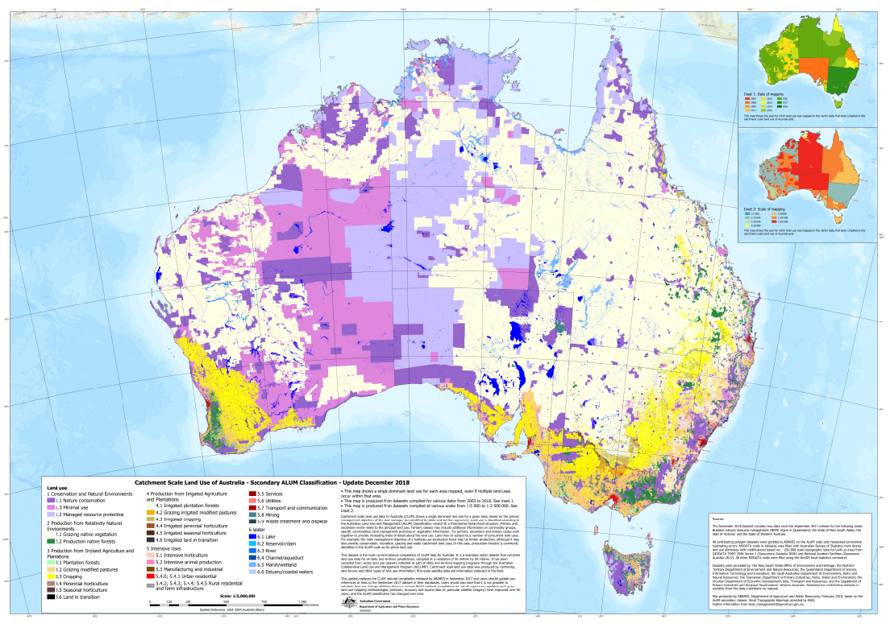

Descriptive information

**[Author(s)  
and/or Stakeholder(s):](http://data.daff.gov.au/anrdl/metadata_files/pb_mcas31s9abl_03111a01.xml" \l "Stakeholders)**

Acknowledgements: This dataset was produced by Australian Bureau of Agricultural and Resource Economics and Sciences (ABARES) within the Australian Government Department of Agriculture and Water Resources as part of the Australian Collaborative Land Use and Management Program (ACLUMP). ACLUMP, of which ABARES is a partner, is a consortium of Australian Government, and state and territory government partners that promotes the development of nationally consistent land use, land cover and land management practice information for Australia. Datasets were provided by: the New South Wales Office of Environment and Heritage; the Northern Territory Department of Environment and Natural Resources; the Queensland Department of Environment and Science; the South Australian Department of Environment and Water; the Tasmanian Department of Primary Industries, Parks, Water and Environment; the Victorian Department of Jobs, Precincts and Regions; and the Department of Primary Industries and Regional Development, Western Australia.

Constraints

**LEGAL CONSTRAINTS ASSOCIATED WITH THE MATERIAL**

**Limitation on the use of the material:**

The Australian Government acting through ABARES has exercised due care and skill in the preparation and compilation of the information and data set out in this publication. Notwithstanding, ABARES, its employees and advisers disclaim all liability, including liability for negligence, for any loss, damage, injury, expense or cost incurred by any person as a result of accessing, using or relying upon any of the information or data set out in this publication to the maximum extent permitted by law.

**Constraints on using the material:**

copyright

**Other constraints:**

Licence type:Copyright  
(c) Commonwealth of Australia 2019  
All material in this publication is licensed under a Creative Commons Attribution 4.0 Australia Licence, save for content supplied by third parties, logos and the Commonwealth Coat of Arms.

This publication (and any material sourced from it) should be attributed as: ABARES 2019, Catchment Scale Land Use of Australia – Update December 2018, ABARES, Canberra, March CC BY 4.0. <https://doi.org/10.25814/5c7728700fd2a>

Additional information about this material

**Purpose for which the material was obtained:**

This catchment scale land use dataset for Australia provides the best available land use mapping information for Australia’s regions as at December 2018. It is used by the Department of Agriculture and Water Resources, state agencies and regional natural resource management groups to address issues such as agricultural productivity and sustainability, biodiversity conservation, biosecurity, land use planning, natural disaster management and natural resource monitoring and investment. The data vary in currency (2003 to 2018) and scale (1:5 000 to 1:250 000).

**Progress status of this material:**

Completed

**Maintenance and Update Frequency:**

as needed

**KEYWORD(S)**

**ANZLIC Search Words:**

AGRICULTURE  
AGRICULTURE mapping  
LAND  
LAND survey  
LAND Use  
LAND Use maps  
LAND Use classification

**General Keywords:**

Australian Collaborative Land Use and Management Program (ACLUMP)

**TOPICS**

**ABARES Topic categories:**

Agriculture  
Land Use  
Environment and Natural Resource Management  
Models, Risk, Spatial Data and Datasets

**ISO topic categories:**

farming  
environment  
biota

**SPATIAL EXTENT(S)**

**Extent**

**Description of spatial extent:**

Australian Land

**Spatial bounding box included in:**

North: -8.20 degrees; South: -44.37 degrees; East: 157.23 degrees; West: 109.49 degrees.

**Spatial area included in:**

Australian Mainland  
Australia excluding external territories

**Projection:**

EPSG::3577

**Coordinate reference details: Well-Known Text:**

PROJCS["GDA94 / Australian Albers",GEOGCS["GDA94",DATUM["D_GDA_1994",SPHEROID["GRS_1980",6378137,298.257222101]],PRIMEM["Greenwich",0],UNIT["Degree",0.017453292519943295]],PROJECTION["Albers"],PARAMETER["standard_parallel_1",-18],PARAMETER["standard_parallel_2",-36],PARAMETER["latitude_of_origin",0],PARAMETER["central_meridian",132],PARAMETER["false_easting",0],PARAMETER["false_northing",0],UNIT["Meter",1]]

**RESPONSIBILITY FOR THIS MATERIAL**

**custodian**

Department of Agriculture and Water Resources: Australian Bureau of Agricultural and Resource Economics and Sciences  
Data Manager  
GPO Box 858  
CANBERRA CITY  
Australian Capital Territory 2601 AUSTRALIA  
Voice: +61 2 6272 3933

dataman@agriculture.gov.au

**publisher**

Department of Agriculture and Water Resources: Australian Bureau of Agricultural and Resource Economics and Sciences  
GPO Box 858  
CANBERRA CITY  
Australian Capital Territory 2601 AUSTRALIA  
Voice: +61 2 6272 3933

dataman@agriculture.gov.au

**CONTACT(S) WHEN INQUIRING ABOUT THIS MATERIAL**

**pointOfContact**

Department of Agriculture and Water Resources: Australian Bureau of Agricultural and Resource Economics and Sciences  
Data Manager  
GPO Box 858  
CANBERRA CITY  
Australian Capital Territory 2601 AUSTRALIA  
Voice: +61 2 6272 3933

dataman@agriculture.gov.au

**PROCESS USED TO GENERATE THIS MATERIAL**

**Lineage Statement**

**Lineage:**   
ABARES has produced this raster dataset from vector catchment scale land use data provided by state and territory agencies, as follows: Catchment Scale Land Use Mapping for the Australian Capital Territory 2012; 2017 NSW Land Use v1.0; Northern Territory Land Use Mapping 2016-17; Land use mapping - Queensland current (March 2018); South Australia Land Use (ACLUMP) 2017; Tasmanian Land Use 2015; Victorian Land Use Information System (VLUIS) 2016-17, Victorian Northern Irrigation Region 2016; Catchment Scale Land Use Mapping for Western Australia 2018. Links to land use mapping datasets and metadata are available at the ACLUMP data download page at <http://www.agriculture.gov.au/abares/aclump/pages/land-use/data-download.aspx>.

State and territory vector catchment scale land use data were produced by combining land tenure and other types of land use information, fine-scale satellite data and information collected in the field, as outlined in 'Guidelines for land use mapping in Australia: principles, procedures and definitions, 4th edition' (ABARES 2011). The Northern Territory, Queensland, South Australia, Tasmania, Victoria and Western Australia were mapped to version 8 of the ALUM classification (‘The Australian Land Use and Management Classification Version 8’, ABARES 2016). The Australian Capital Territory was mapped to version 7 of the ALUM classification and converted to version 8 using a look-up table based on Appendix 1 of ABARES (2016). Victoria converted the VLUIS vector data to the ALUM classification, based on an agreed method using Valuer General Victoria land use codes, land cover and land tenure information.

ABARES converted all contributing polygon datasets to rasters based on the ALUM code using a model in ESRI ArcGIS Pro. These datasets were then mosaicked using another model in ArcGIS Pro and clipped to the GEODATA COAST 100K coastline (Geoscience Australia 2004). NODATA voids in Adelaide were filled with Australian Bureau of Statistics 2016 mesh blocks land use attributes with modifications based on: 1:250 000 scale topographic data for built up areas from GEODATA TOPO 250K Series 3 (Geoscience Australia 2006) and National Aviation Facilities (Geoscience Australia 2012). All other NODATA voids were filled using the ArcGIS focal statistics command.

**Positional Accuracy:**   
The scale of the source data varies from 1:5 000 to 1:250 000. See individual land use mapping dataset metadata for specific measures of accuracy.  
**Attribute Accuracy:**   
The methods for mapping and classifying land use adhere to the standards outlined in 'Guidelines for land use mapping in Australia: principles, procedures and definitions, 4th edition' (ABARES 2011) with the exception that most of the mapping was attributed to the newest version of ‘The Australian Land Use and Management Classification Version 8’ (ABARES 2016). Datasets mapped to version 7 of the ALUM Classification were converted to version 8 using a look-up table based on Appendix 1 (ABARES 2016).  
**Logical Consistency:**   
All input polygon datasets were checked for topological consistency.   
**Completeness:**   
Complete. NODATA voids were filled with ancillary data and modelling, as described in lineage.

Information about the product description

**Parties responsible for description**

**Description custodian**

Department of Agriculture and Water Resources: Australian Bureau of Agricultural and Resource Economics and Sciences  
Data Manager  
GPO Box 858  
CANBERRA CITY  
Australian Capital Territory 2601 AUSTRALIA  
Voice: +61 2 6272 3933

dataman@agriculture.gov.au

**Description publisher**

Department of Agriculture and Water Resources: Australian Bureau of Agricultural and Resource Economics and Sciences  
GPO Box 858  
CANBERRA CITY  
Australian Capital Territory 2601 AUSTRALIA  
Voice: +61 2 6272 3933

dataman@agriculture.gov.au

**Description originator**

Department of Agriculture and Water Resources: Australian Bureau of Agricultural and Resource Economics and Sciences : Land and Spatial Analystics   
GPO Box 858  
CANBERRA CITY  
Australian Capital Territory 2601 AUSTRALIA  
Voice: +61 2 6272 3933

dataman@agriculture.gov.au

Additional Metadata

**References**

ABARES 2011, *Guidelines for land use mapping in Australia: principles, procedures and definitions*, A technical handbook supporting the Australian Collaborative Land Use and Management Program, 4th edition, Australian Bureau of Agricultural and Resource Economics and Sciences, Canberra, available at [data.daff.gov.au/data/warehouse/pe_abares99001806/GuidelinesLandUseMappingLowRes2011.pdf](http://data.daff.gov.au/data/warehouse/pe_abares99001806/GuidelinesLandUseMappingLowRes2011.pdf%20).

ABARES 2015, *Addendum to the Guidelines for land use mapping in Australia: principles, procedures and definitions*, 4th edition, Australian Bureau of Agricultural and Resource Economics and Sciences, Canberra, available at [data.daff.gov.au/data/warehouse/pe_abares99001806/AddendumGuidelinesLandUseMapping2015_v1.0.0.pdf](http://data.daff.gov.au/data/warehouse/pe_abares99001806/AddendumGuidelinesLandUseMapping2015_v1.0.0.pdf).

ABARES 2016, *The Australian Land Use and Management Classification Version 8, Summary*, Australian Bureau of Agricultural and Resource Economics and Sciences, Canberra, available at [agriculture.gov.au/abares/aclump/Documents/ALUMv8.pdf](http://www.agriculture.gov.au/abares/aclump/Documents/ALUMv8.pdf).

ABARES 2016, *The Australian Land Use and Management Classification Version 8, Detailed*, Australian Bureau of Agricultural and Resource Economics and Sciences, Canberra, available at [agriculture.gov.au/abares/aclump/Documents/ALUMCv8_Handbook4ednPart2_UpdateOctober2016.pdf](http://www.agriculture.gov.au/abares/aclump/Documents/ALUMCv8_Handbook4ednPart2_UpdateOctober2016.pdf).

ABARES 2018, *Land Use Data Download*, Australian Bureau of Agricultural and Resource Economics and Sciences, Canberra, available at [agriculture.gov.au/abares/aclump/pages/land-use/data-download.aspx](http://www.agriculture.gov.au/abares/aclump/pages/land-use/data-download.aspx).

Australian Bureau of Statistics 2016, 1270.0.55.001 - *Australian Statistical Geography Standard (ASGS): Volume 1 - Main Structure and Greater Capital City Statistical**Areas*, July 2016, accessible at [abs.gov.au/AUSSTATS/abs@.nsf/DetailsPage/1270.0.55.001July%202016?OpenDocument](http://www.abs.gov.au/AUSSTATS/abs@.nsf/DetailsPage/1270.0.55.001July%202016?OpenDocument).

Geoscience Australia 2004, *GEODATA COAST 100K 2004,* Geoscience Australia, Canberra, accessible at <https://data.gov.au/dataset/ds-ga-a05f7892-eae3-7506-e044-00144fdd4fa6>

Geoscience Australia 2006, *GEODATA TOPO 250K Series 3*, Geoscience Australia, Canberra, accessible at [ga.gov.au/metadata-gateway/metadata/record/63999/](http://www.ga.gov.au/metadata-gateway/metadata/record/63999/).

Geoscience Australia 2012, *National Aviation Facilities*, Geoscience Australia, Canberra, accessible at [services.ga.gov.au/site_3/rest/services/Aviation_Facilities/MapServer](http://services.ga.gov.au/site_3/rest/services/Aviation_Facilities/MapServer).